**Laser Data Transfer**

**Senior Design Documentation**



Department of Electrical Engineering & Computer Science

University of Central Florida

Fall 2015-Senior Design I

Group #32

Derek Clark Photonic Science and Engineering

Joshua Jordan Photonic Science and Engineering

Kenneth Figueiredo Computer Engineering

Table of Contents

1 Executive Summary…………………………………………………………Page2

2 Project Description………………………………………………………….Page 3

2.1 Motivation and Goals…………………………………………………. Page 3

2.2 Milestones………………………………………………………….….. Page 5

2.3 Requirements and Specifications…………………………………… Page 5

2.4 Impact of Design Constraints……………………………………….. Page 7

3 Communication Technologies……………………………………………. Page 7

3.1 Guided Transmission……………………………………………... Page 8

3.2 Unguided Transmission…………………………………………….Page 8

4. Optical receiver subsystems………………………………………………Page 8

4.1 Photodetectors………………………………………………………… Page 9

4.2 Noise……………………………………..……………………………. Page 19

4.3 Amplification……………………………………………………………Page 21

4.4 Filtering …………………………………………….…………………..Page 25

4.4 Receiver Design……………………………………………………….Page 26

5 Transmitter………………………………………………………………… Page 28

5.1 Laser Types……………………………………………………………Page 28

5.2 Analog vs Digital Communication……………………………………Page 32

5.3 Laser Modulation Types……………………………………………. Page 33

5.4 Laser Safety Standards…………………………………………… Page 39

5.5 Transmitter Design………………………………………………… Page 42

6 Power Electronics……………………………………………………… Page 45

6.1 AC Power………………………………………………………… Page 45

6.2 DC Power………………………………………………………… Page 45

6.3 Rectifiers………………………………………………………… Page 46

6.4 Inverters…………………………………………………………… Page 48

6.5 AC to AC Converters………………………………………………. Page 48

6.6 DC to DC Converters……………………………………………… Page 48

6.7 USB to Serial Adapter……………………………………………… Page 48

7 Microcontroller and Peripherals…………………………………… Page 50

7.1 Suitable Microcontrollers for proof of concept………………. Page 51

7.2 Components of the custom prototype boards…………………… Page 52

7.3 Transmitter side of Microcontroller Board……………………… Page 55

7.4 Receiver Microcontroller……………………………………… Page 58

8 Circuits………………………………………………………………… Page 62

8.1 Analog Circuit……………………………………………… Page 62

8.2 Laser Driver Circuit…………………………………………… Page 65

8.3 Photodiode Circuit……………………………………………… Page 75

9.0 Prototype Testing………………………………………………… Page 81

9.1 Testing Environment……………………………………… Page 82

9.2 Transmitter Testing…………………………………………… Page 82

9.3 Transmitter Subsystem Testing…………………………… Page 83

9.4 Photodiode Testing……………………………………………… Page 83

9.5 Microcontroller and Peripheral Testing……………………… Page 84

10 Administrative Content………………………………………… Page 87

10.1 Budget……………………………………………………… Page 87

12 Conclusion………………………………………………………… Page 89

Appendix A: Permissions…………………………………………… Page 91

Appendix B: Datasheets……………………………………………

Appendix C: Works Cited…………………………………………… Page 91

Appendix D: Full Code……………………………………………

**1.0 Executive Summary**

Since the dawn of the digital age the demand to move large amounts of information as fast as possible has been unquestionable. The group has decided to continue the advancement in the movement of information by creating the LDT project. The group feels that their efforts and expertise in their respective degree fields can contribute greatly to this initiative. We envision a product that can surpass present consumer demand for moving, or transmitting large magnitudes of information at comparable speeds to current industry technology. The process of transmitting this information begins with a computer. A digital signal containing all the desired information will be sent to a transmitter box by means of a USB to serial converter. The transmitter will obtain its power directly from the USB to serial connection. The digital signal will then travel to a microcontroller circuit with a laser diode driver integrated into it. This laser diode driver will then condition, or modulate the digital signal to extremely high frequencies. This signal will then exit the microcontroller circuit and enter the laser. The laser will convert the incoming electrical signal to an optical signal, amplify the signal and transmit it through space to a phototransceiver that will collect the incoming signal. The high and low values of the collected signal will be processed and sent to an optical to electrical converter. Once the signal is electrically converted it can be sent through a second microcontroller circuit and be routed through a second serial to USB converter to a computer. The final result is information that has been successfully sent from one computer to another without any physical interaction. Maximizing the amount of correctly transferred information as fast as possible will be the top priority of the LDT project. Other features such as portability, security, and energy efficiency will also be incorporated at no expense to the defined top priority. The LDT project also boasts small safety features. The transmitter will contain a visible LED light to signify the laser is on. The receiver will also contain a series of lights that will identify the amount of power that is being collected. This will serve as a means of establishing a strong and secure link between the transmitter and receiver. Both the transmitter and receiver will also stand on adjustable legs. This will allow both components to be fully adjustable. With these features in mind the group feels that the LDT project will be a serious competitor in the wireless communications industry; an industry that has been dominated by Wi-Fi for far too long. The group feels that the rugged design of both the transmitter and receiver, along with the portability of both, will offer the consumer with a unique and simple solution to transferring data from anywhere. To succeed in constructing the LDT project each group member will research and apply their respective knowledge toward designing a desirable product. This product will be comprised in a cost efficient way and will utilize effective coding techniques to ensure a quality product is produced. This product will also strictly adhere to ABET standards and constraints. Upon completion of the design phase the group will go through an extensive testing phase that will guarantee that all hardware and software components are functioning as designed. The final product, after all consideration, will be a revolutionizing product that will change the marketplace forever.

**2.0 Project Description**

**2.1 Project Motivation and Goals**

The motivation behind the idea of creating a channel of communication through the air between transmitter and receiver began with current projects in production such as Light Fidelity, or Li-Fi. Li-Wi is a relatively new field in which lasers in the visible spectrum will carry information at great speeds. The idea of Li-Fi is to get past the limitation of Radio frequency bandwidths that services like Wi-Fi are restricted to. The designers of the LDT project further found inspiration by imagining a fiber optic communications link without the fiber. The designers of LDT believed this to not only be possible but that a system can be designed that can achieve data transfer speeds comparable to current Wi-Fi technology. The Laser Data Transfer project was born.

There is an increasing need for the fastest transfer rates possible. A fiber optic cable can provide users with the fastest data transfer speeds technology has to offer. Some circumstances, however enlist wireless technology to transmit data. Currently Wi-Fi technology leads the industry for wireless data transfer. Wi-Fi has an inherent limitation of only being able to broadcast in a certain radio frequency range. This radio frequency bandwidth limits the amount of data that can be sent wirelessly. This is a direct effect of the radio frequencies only being able to be so efficient, spectrally. This spectral efficiency creates a finite number of radio frequencies, and they are all almost be utilized. The LDT project is designed to utilize frequencies far beyond the radio frequency, thereby bypassing the radio frequency limitations. Typical Wi-Fi networks operate on 2.4 GHz - 5.6 GHz frequencies, whereas the LDT project will operate on THz frequencies.

The LDT project is unique from Li-Fi because the LDT project will be a connection using direct line of sight to transfer data from transmitter to receiver. The laser beam will have a conical shape to allow for an angle of accepted data transmission. Figure 2.1-1 is a diagram of a transmitter and a signals potential path, in red. The receiver would be able to move within that signal path to receive the data being transferred.

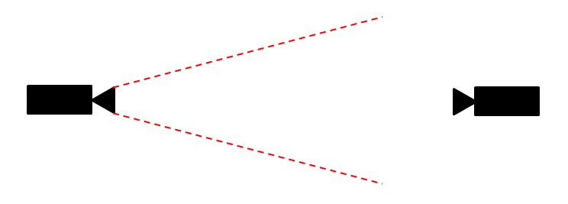

**Receiver**

**Transmitter**

*Figure 2.1-1*

The goal of the LDT project is to continue the growth of the digital era by getting past the limitations that current technology has. With the continued advance in technology data communication demands have never been greater. Fiber optic communication projects like Google Fiber wire are being load tested and employed nationwide to offer users affordable data speeds of up to 1Gbps download speeds. The limiting factor of the entire data transmission process will soon be Wi-Fi. If this product were to replace Wi-Fi it would be a profitable and marketable in all areas of wireless communication. The LDT project can be used to stream high bandwidth services such as Netflix in high definition, Cloud backup and recovery, virtual desktops, Office 365, video calling and even more.

Another goal the designers of the LDT project have is to design a system that offers its users secure transfer of data. The integration of technology in daily life has brought up security concerns. We now share credit card information, pay bills online, browse and purchase goods online, and even file taxes online. It is no wonder how people get their identities and other personal information stolen from them. The LDT project hopes to minimize these risks by having a directional link to a transmitter. From a security perspective this link is superior to Wi-Fi, where anyone within a radial range from a Wi-Fi transmitter can gain access to all of the devices connected to it. The LDT project is also more easily confined to either indoor or outdoor functionality. This property of the LDT project stems from the fundamental characteristics of optical frequencies. Frequencies in the optical, near and mid infrared spectrum cannot travel through solid objects, such as walls, metal and the ground. Imagine a data transmission system that is portable, secure, and can achieve data lighting fast data speeds. This system can either be relocated according to the user’s needs, or multiple transmitters can be employed similar to security camera systems that can detect users on network to offer directional internet on demand. This detection system can be more energy efficient as it can be turned on and off as required.

The last goal of the LDT project is to promote health to humanity. The average United States citizen is subjected to Radio frequency radiation almost 24 hours a day. A concern is growing that too much exposure to these radio frequencies is unhealthy. The implementation of the LDT project would eliminate the strongest intensity radio frequencies that reside in family homes, replacing them with optical frequencies that the human body has been exposed to since the beginning of time. The LDT project is guaranteed to be healthier for all humanity. All of these goals will be met when this product is finished, creating a marketable product and will be instantly employable worldwide.

**2.2 Milestones**

As this project will span at least five months from beginning to end, it will prove worthwhile to set some milestones to ensure we are on track for our completion date.

* Milestone 1: Complete initial design document
* Milestone 2: Obtain and acquire parts for prototype build
* Milestone 3: Setup prototype circuits to connect to transmitter and receiver.
* Milestone 4: Build of the program for transmitter and receiver functions on the prototype.
* Milestone 5: All tests pass on the prototype board
* Milestone 6: Acquire custom PCB
* Milestone 7: Setup circuits to connect transmitter and receiver to the PCB
* Milestone 8: Build of the program for transmitter and receiver functions on the custom PCB
* Milestone 9: All tests pass on the custom PCB board
* Milestone 10: Complete final document

These tasks will be roughly completed around the time shown in the following chart labeled Figure 2.2-1*.*

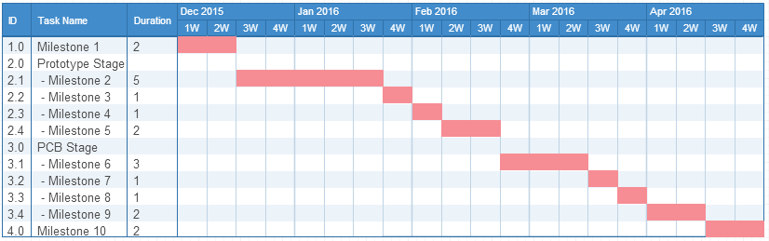*Figure 2.2-1*

As this is an estimation of our project lifecycle, the times needed for each step may not be guaranteed this chart will be updated accordingly with the final design document.

**2.3 Requirement and Specifications**

**2.3.1.1 Physical Specifications**

The following is a list of physical specifications. These specifications will be strict guidelines in the design of the LDT project. The primary physical specifications are:

* Fast Data Transfer – The primary goal for the LDT project is to achieve a bit rate of over 1Mbps download speeds from transmitter to receiver.
* Lightweight – Both the transmitter and receiver will not exceed 5 pounds. This will preserve mobility.
* Durable – Transmitter and Receiver housings will withstand everyday wear and tear from movement. The housings will withstand a force of 20 pounds from any given side.
* Affordable – The project will not exceed an overall budget of $500.00. This includes mistakes and any equipment needed to fabricate the project.
* Long Lifetime – Once fabricated the LDT project will be designed to last over 3 years of use.
* Low Maintenance – Upon completion of the project the user will only be required to remove dust from the units via pressurized air at least once every 6 months.
* Caution Light – The transmitter house must contain 1 LED that lights up signifying when the laser is on.
* Intensity Lights – Alignment can be an issue with laser systems. It is required to display 3 LED lights on the receiver visible to a user at the transmitter box. Each light will be associated with low, medium and high.

**2.3.1.2 Laser Specifications**

In order to meet the specifications listed in the previous section there are certain specifications that that transmitting laser must meet. Therefore, the transmitting laser must:

* Wavelength – The laser must operate at 1.55µm. This is one of the safest and most useful wavelengths to use.
* Cost – In order to stay within budget the laser must be absolutely no more than $150.00
* Drive Current – The laser must have a drive, or operating, current at between 20mA-70mA. Maintaining low operating currents will allow the laser to be interchangeable with various breadboards for prototyping.
* Short Rise and Fall Times – The LDT project places a strict limit on the rise and fall times of a signal pulse to within picoseconds
* Variable Drive Current – Along with a specific operating current, the current must be able to swing at least 30mA to allow for the laser to properly amplify the signal.

**2.3.1.3 Power Specifications**

To ensure that the project meets all its specifications the following specifications have been placed on the power system:

* Low Voltage – DC voltage entering both the transmitter and receiver units will not exceed 12V.
* Stable Voltage – Voltage throughout the entire system must not fluctuate more than 0.5V after turn on.
* Size – DC to DC regulators will be limited to 100mm x 100mm.
* Low Cost – The cost to power the transmitter and receiver combined must not exceed $70.00.

**2.3.2 Software Requirements**

To achieve the specifications and goals listed in the above sections, there are certain specifications that the software must adhere to and perform up to in order for the entire LDT to function properly. The software needs to be:

* User Friendly – need to ensure that the software is not overly difficult to use as it will be presented.
* Efficient – need to ensure that the software does not have any extraneous loops or irrelevant subroutines that could potentially cause a slowdown of the entire project.
* Structured – need to ensure that the software is well structured and organized as this will streamline the process for debugging and testing.
* Precise – need to ensure that the software is precise, as it will be controlling the MCU to output current, so we do not cause any damage to the prototype board or the PCB.
* Documented – need to ensure that the software is properly commented, as this will ensure proper understanding of thought processes of coding decisions between the group.
* Functional – need to ensure that the model pipeline for both the transmitter and receiver sides are functional, as the project will fail if either side cannot perform their duties.

**2.3.3 Constraints**

* Transportable – The transmitter and receiver units will be easily disassembled for transport. Both the receiver and transmitter will be stackable.
* Connectivity – The system will be easily transferrable from computer to computer. This allows a broader range of customers.
* Easy Setup – The LDT project must breakdown into as few parts as necessary to facilitate an easy setup. Simple instructions will be located on each unit to guide users through the set up process.
* Powered by a 120VAC standard wall outlet.

|  |  |
| --- | --- |
| Receiver Unit | $113.45 |
| **Total** | **$378.43** |

This grand total for the LDT project meets the specification that was placed in effect. An excess in our budget will serve the project in case of accidents or repairs.

**3.0 Data Communication Technologies**

As our project will be transmitting data over laser as the medium, it will be useful to look into other data communication technologies as many share similarities to our medium. There are two categories of transmission medium that will be discussed in this section, which are guided transmission, and its counterpart, unguided transmission. Our laser guided transmission will need to have a comparable speed to at least some of these other medium bit rates.

**3.1. Guided Transmission**

A guided transmission is a link of networks via a physical connection such as fiber optics, or a copper wire connection such as through telephone lines or coaxial cables. This type of connection requires heavy and massive infrastructure to be able to use in a large scale model. These connections however usually end up being paired up and using previously existing communication lines such as television cable lines or telephone lines.

**Dial-up and DSL:** Dial-up and Digital Subscriber line (DSL) are physical connections that use wired telephone service lines to transmit data to internet connections. Dial-up, now an outdated, slow technology was originally one of the most widely used ways to connect to the internet. It was very slow with max bit rates were averaging around 56Kbps. DSL was similar in this respect as it also ran over copper telephone lines. DSL technology is still being expanded upon to this day with a max speed reached in a controlled condition of 10Gbps, however typical speeds range from 256Kbps to 100Mbps.

**Coaxial:** Cable internet access uses the existing cable television infrastructure to allow for high bit rates to be reached with coaxial cables as the medium. These cables usually allow for bitrates up to 400 Mbps. One of the key disadvantages of this physical medium though is that populations of users share available bandwidth. Same neighborhoods with cable internet may share this bandwidth which will slow down the connection for everyone.

**Fiber Optic:** Fiber optic cables are a physical link between networks which are currently on the rise as it is one of the fastest physical links currently available. It has such a high bit rate, that currently electrical cables have reached their physical limitations at 10 Gbps. The current record bitrate is currently set at 1.05 Petabits/s by NEC corp. and Corning Inc.

**3.2. Unguided Transmission**

An unguided transmission is a link of networks via electromagnetic, usually omnidirectional, waves. These connections have gained massive traction due in part to the rise of smartphones and mobile communications. The infrastructure needed is usually much cheaper than setting up a physical link. These connections in relation to data communication include Wi-Fi and Bluetooth.

**Wi-Fi:** Wi-Fi is a local area wireless computer networking technology based on the IEEE 802.11 standard. Wi-Fi is the most widely used wireless communication within local area networks as it has a fairly large range, decent wall penetration and is very affordable to setup. Currently the 802.11ad protocol has a max bit rate of 6.75 Gbps.

**Bluetooth:** Bluetooth is device-to-device standard for exchanging data over short distances. It was originally based upon the IEEE 802.15.1 standard but no longer supports the standard. Its current max bit rate is 25Mbps.

**4. Optical Receiver Subsystems**

The four main parts of an optical receiver subsystem include a photodetector, an amplifier, a filter, and a signal processor. Figure 4.0-1 is a block diagram for the optical subsystem.

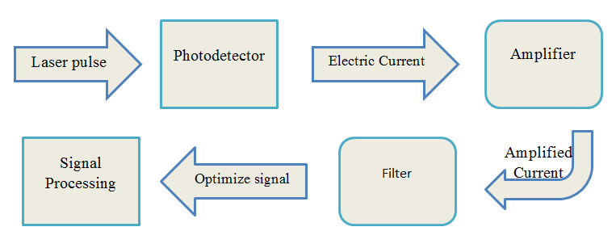

*Figure 4.0-1Block Diagram of Optical Subsystem*

**4.1. Photodetectors**

A photodetector is a semiconductor device that electrically detects optical signals and can convert the optical signal into an electrical signal. Depending on the operating wavelength, the ideal photodetector should have high sensitivity, high speed response, low voltage, minimum noise, and be small in size. For a photodetector to work it must be able to generate carriers from incident light, transport carriers by current gain, and have current interaction with an external circuit for output signal. The output is an electrical signal that has various specifications such as signal power, impedance level and bandwidth. A typical photodetector consists of a photodiode and an electrical circuit.

**4.1.1. Photoelectric Effect**

First discovered in 1887 by Heinrich Hertz and later explained in 1905 by Albert Einstein, the photoelectric effect is a method used to detect forms of light. As light is incident on a specific material, electrons are emitted and energy is released. This phenomenon is applied to construct the photodetector resulting in the conversion of light energy into electrical energy. The energy and number of emitted electrons can be measured as intensity and frequency of light.

Any discrete emitted electron energy is independent of incident light intensity and increases linearly with a frequency above a specific threshold frequency. Additionally, the number of electrons emitted per second increases linearly with incident light intensity and is independent of frequency. Furthermore, there are three different methods of converting light energy into electrical energy which are known as the photoconductive, photovoltaic, and photoemissive effects. Figure 4.1-1 is a visual representation of the photoelectric effect.

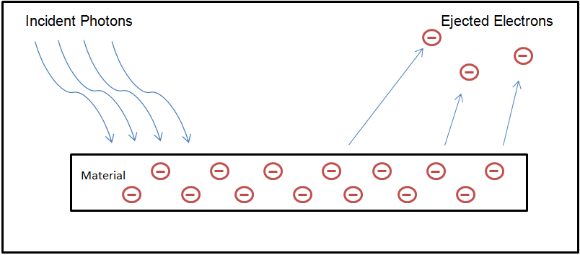

*Figure 4.1-1: As incident light, photons, hit the surface of a material an electron will be ejected.*

**4.1.1.1. Photoconductive**

The photoconductive effect results in the increase of electrical conductivity of a device when exposed to a light source, in other words the current flows through the device much easier when exposed to light. As light is incident on a device, such as a semiconductor, the incident photons liberate discrete electrons resulting in an increase in electron-hole pairs. However, when the light is no longer incident, the device becomes idle. Taking advantage of the photoconductive effect results in various applications such as the photoresistor, used in street lights, and photocopying.

**4.1.1.2. Photovoltaic**

The photovoltaic effect uses solar cells, a semiconductor device, to convert light into an electrical current or voltage. The photon-electron interaction is similar to what takes place with the photoconductive effect except the semiconductor device used in the solar cell has a different chemical structure. The materials in the solar cell create a chemical imbalance that accelerates the electrons resulting in a voltage. The photovoltaic effect is used for solar panels and photodiodes.

**4.1.1.3. Photoemissive**

Considered the oldest method of converting light into electrical energy, photoemission uses photoemissive cells. These cells are sealed a glass vacuum tube with a metal plate inside. As light hits the metal it causes electrons to move resulting in an active current through the circuit.

**4.1.2. Photoconductor**

A photoconductor is a resistor, where the resistance is a function of the incident light intensity. The device consists of a semiconductor with Ohmic contacts connected to the opposite ends and has an increase in conductivity when light hits the surface, where most of the photons will be absorbed and is shown in figure 4.1-2. This receiver is used to measure quantum efficiency or gain, response time, and sensitivity. Photoconductors are cheap due to their simplicity, toughness, and gain profile making them a relatively cheap photodetector.

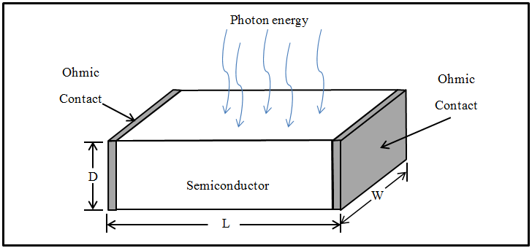

*Figure 4.1-2: A schematic of a photoconductor has Ohmic contacts sandwiched between a piece of semiconductor material.*

**4.1.3. Quantum Efficiency**

Quantum efficiency is defined as the number of electron-hole pairs generated per incident photon and varies by both the semiconductor material property and the devices physical structure: Quantum efficiency is represented by , where is the photocurrent, is the electron charge, and is the incident optical power and is the photon energy. Figure 4.1.3-1 represents the quantum efficiency of various photodetectors.

**4.1.4. Responsivity**

Responsivity is the ratio of photocurrent to input optical power in units of Ampere per Watt and is represented by , where is the photocurrent produced and is the input optical power. There are four components when photon energy is incident on a photodiode reflection from the front surface, transmission through the detector without absorption, absorption by ionizing collisions, and other absorption mechanisms. Figure 4.1.4-1 represents the responsivity vs wavelength for two common photodiode materials.

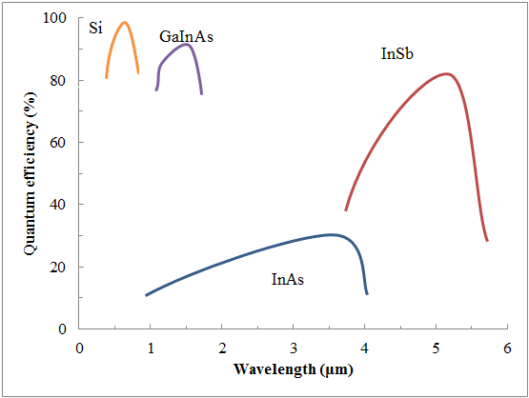

*Figure 4.1.4-1 (Above): This graph represents the quantum efficiency versus wavelength for various materials used as photodetectors.*

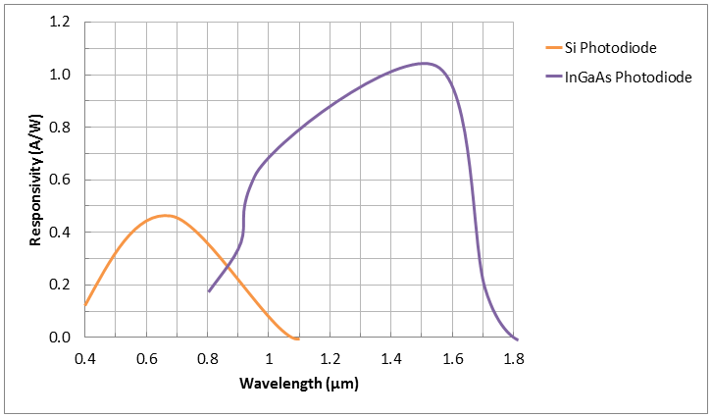

*Figure 4.1.4-2 This graph represents the spectral responsivity of Silicon and InGaAs materials. The graph details responsivity vs wavelength.*

**4.1.5. PN Photodiode**

A PN photodiode is an n-type material bonded with a p-type material and is basically a PN junction under reverse bias and the device configuration is shown in Figure 4.1.5-1. A PN photodiode is a PN junction with an optical window and is a device whose conductivity is sensitive to the intensity of incident light. Due to a small depletion layer the PN photodiode has two major flaws which include having a minimal absorption at long wavelengths and a small junction capacitance. The intensity of the incident light is a measurement of the current that flows into the photodiode. Silicon is the most common used material as a photodiode and has a wavelength less than 1μm. These photodetectors are fabricated to be small as to minimize junction capacitance.

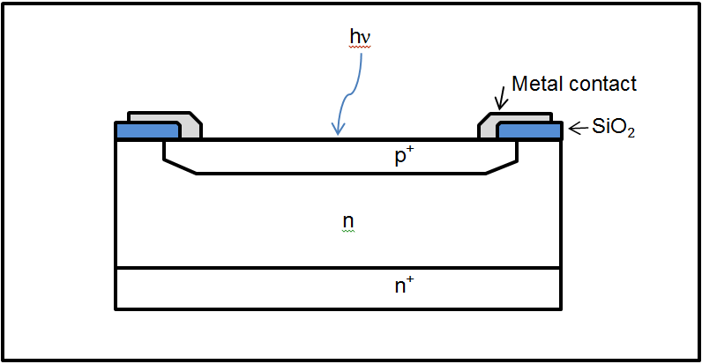

*Figure 4.1.5-1: The device configuration for a high-speed PN photodiode.*

**4.1.6. PIN photodiode**

A PIN photodiode is similar to a PN photodiode but has a lightly doped intrinsic layer between the p- and n-type regions of the semiconductor and figure 4.1.6-1 shows the device configuration. The added intrinsic layer in the PIN photodiode increases the depletion layer resulting in a smaller junction capacitance and a greater absorption at longer wavelengths. By adding the intrinsic layer and adjusting the doping levels in each region the design of the semiconductor will optimize the quantum efficiency and frequency response.

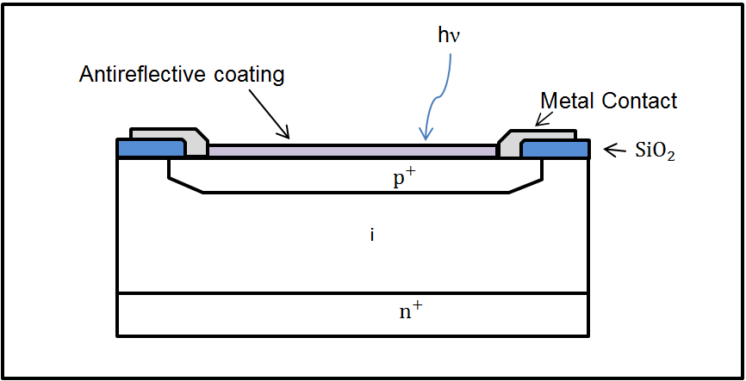

*Figure 4.1.6-1: The device configuration for a high-speed PIN photodiode.*

**4.1.7. Metal-Semiconductor Photodiode**

Used as a high-efficient photodetector, the metal-semiconductor photodiode requires a very thin layer of metal, ~10 nm, and an antireflective coating. The combination of a thin metal and an antireflective coating can avoid absorption and reflection of incident light and is shown in Figure 4.1.7-1. Depending on the photon energies and by adjusting the voltage, this photodiode can operate in three different modes. One mode is used to study the hot-electron transport in metal thin films by determining the Schottky-barrier height.

Accordingly, the second mode results in similar characteristics of a PIN photodiode and lastly can be used as an avalanche photodiode. Material selection is a major factor, an ideal metal and antireflective coating will result in maximizing the absorption at the semiconductor air interface. A metal-semiconductor photodiode has an absorption coefficient that is compatible with both visible and ultraviolet light.

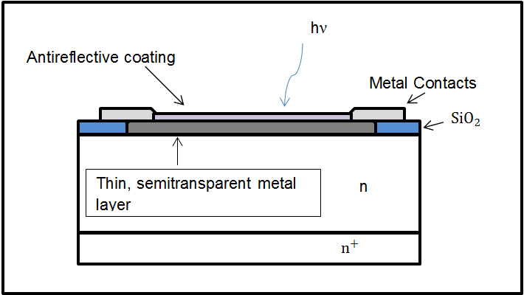

*Figure 4.1.7-1: The device configuration of a high-speed metal-semiconductor photodiode.*

**4.1.8. Avalanche Photodiode (APD)**

Operating at high reverse bias voltages will lead to internal current gain due to avalanche multiplication and is shown in figure 4.1.8-1. This diode works fast resulting in high gains and is very sensitive to bias voltage and temperature. With that, the current gain-bandwidth can be as high as 100 GHz, responding to microwave frequency modulated light. This diode has similar quantum efficiency and responsivity to non-avalanche photodiodes.

Two important properties that occur with the avalanche photodiode include noise and avalanche gain. Avalanche gain, the impact of ionization, allows for very large currents to be generated and multiplies single current, background current, and dark current. However, the avalanche gain must be uniform over the whole surface where light is incident upon the device. Applications used are for high frequency.

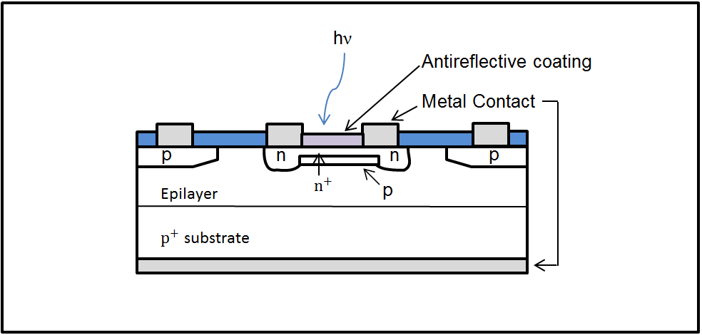

*Figure 4.1.8-1: The device configuration of a guard-ring photodiode structure.*

**4.1.9. Phototransistor**

The phototransistor is used to enhance the optical absorption. This device is often compared to the avalanche photodiode and doesn’t require high voltages nor creates high noise. Gain occurs at low frequencies and a BJT circuit can be used for a phototransistor. However, the fabrication of this device is much more complicated than that of the photodiode resulting in reduced performance with the high-frequency and is shown in figure 4.1.9-1. This is a bipolar phototransistor and has a large base-collector junction used for collecting light resulting in a high current-transfer ratio.

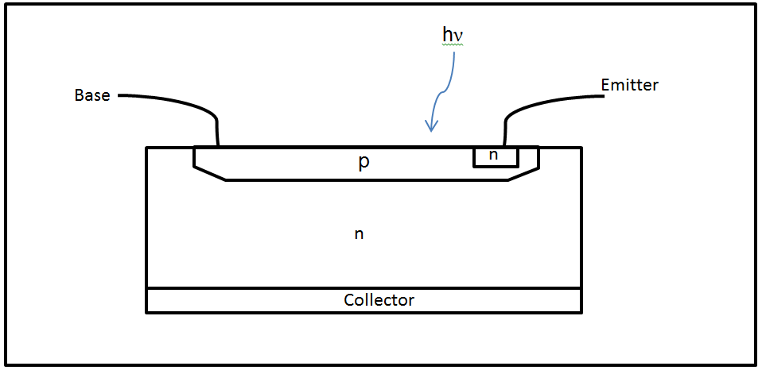

*Figure 4.1.9-1: The device configuration of a bipolar phototransistor.*

**4.1.10. Heterojunction Photodiode**

The junction of this photodiode is made between two semiconductors. Taking advantage of the unique junction, materials can be combined to optimize the quantum efficiency and responsivity at different wavelengths.

**4.1.11 Photodiode Product comparison**

Before choosing a photodiode there are a few parameters to consider. It is known that responsivity affects noise equivalent power, therefore it is only appropriate to choose a photodiode that is within the wavelength range of the laser diode being measured. The laser diode will be emitting at a wavelength of 1.55μm, therefore a photodiode with responsivity within the range of 1. 55μm is desired and an infrared photodiode will be required. InGaAs photodiodes have the responsivity within this wavelength making them the preferred photodiode.

Additionally, the active area of the photodiode is important to consider as it affects the noise equivalent power. A small active area is desired because the square root of the active area is proportional to the generated noise. Furthermore, a smaller active area will not reduce the gain bandwidth as a large active area will. A smaller frequency response is also desired as this will lead to an acceptable level of noise equivalent power.

Optical power damage threshold is an important parameter that will help determine the photodiode to use as we do not want to destroy the photodiode. The laser diode used will produce a maximum output power of 5 mW; therefore the optical power damage threshold must be greater than 5 mW.

Thorlabs has several InGaAs photodiodes available and will be reviewed. Table 4.1.11-1 is a table of the top three photodiode found.

|  |  |  |  |
| --- | --- | --- | --- |
| InGaAs Photodiode | FGA01 | FDGA05 | FGA01FC |
| **Price ($US)** | $56.70 | $134.00 | $144.00 |
| **Key Feature** | High Speed, High Responsivity, and Low Capacitance | High speed and low capacitance, ball lens | High speed and low capacitance, direct fiber couple |
| **Responsivity** | 1.003 A/W | 0.95 A/W | 1.003 A/W |
| **Active area** | Ø 0.12mm | Ø 0.5mm | Ø 0.12mm |
| **Rise Time (5V)** | 300 ps | 2.5 ns | 300 ps |
| **Bandwidth** | 1.167 GHz | 0.14 GHz | 1.167 GHz |
| **Peak Wavelength** | 1550 nm | 1550 nm | 1550 nm |
| **Max Dark Current (5V)** | 2.0 nA | 30 nA | 2.0 nA |
| **Capacitance (5V)** | 2.0 pF | 10 pF | 2.0 pF |
| **Max Reverse Bias Voltage** | 20 V | 20 V | 20 V |
| **Max Reverse Current** | 2 mA | - | 2 mA |
| **Operating Temperature** | -40 to 75 °C | -40 to 85 °C | -40 to 75 °C |
| **Optical Power Damage threshold** | 18 mW | - | 18 mW |
| **NEP** |  |  |  |
| **Package** | TO-46 | TO-46 | TO-46, FC/PC Bulkhead |

4.1.11-1: Specification of three InGaAs photodiodes manufactured from Thorlabs.

After review the top three options Thorlabs has to offer it is clear that FDGA05 can be eliminated as it has the largest active area and largest frequency response of the three, additionally the optical power damage threshold was not specified.

The packaging system used by all three photodiodes is the same with the exception to FGA01FC, which has an additional bulkhead. However, we will eliminate the FGA01FC as a direct fiber couple package is not required for this project. The FGA01 InGaAs photodiode will be use as it as it fits the required specification to properly operate with the laser diode, and it also the cheapest.

The FGA01 uses a TO-46 package size which is shown in figure 4.1.11-1 and has three pins along with a ball lens that has a 1.5 mm diameter.

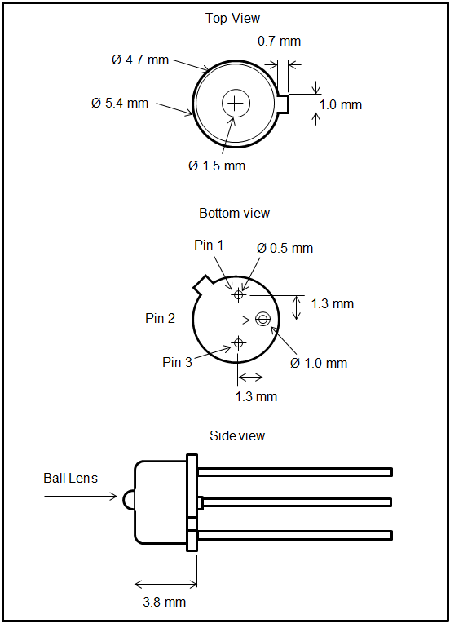

Figure 4.1.11-1: This is the TO-46 package size schematic of the FGA01 InGaAs photodiode manufactured by Thorlabs.

**4.2. Noise**

Noise is an undesired randomly alternating voltage or current that is associated with the desired signal in the receiver. By adding noise to the signal causes a particular amount of uncertainty about the exact value of the signal current or voltage. When the signal is greater than the noise, the uncertainty resulting from the noise can be small and irrelevant. Additionally, when the noise is greater than the signal, the signal may be impossible to obtain.

Furthermore, noise can be characterized as the average noise current and the average squared noise current. Each and every active device component in the receiver produces some noise, including the photodiode. By understanding the noise produced by the circuit in the receiver, the receiver sensitivity can be determined.

**4.2.1. Optical Receiver Noise**

Optical noise can be described by photon noise, photoelectron noise, and gain noise that are associated with random fluctuations.

**4.2.1.1. Photon Noise**

Photon noise is the most fundamental source of noise associated with the random arrival of photons at the photodetector, and is measured by the amount of individual incident photons over a time interval. While under a fixed optical power the resulting photon flux is uncertain however the value of the mean photon flux fluctuates randomly. When incident light is monochromatic and coherent the number of photons adheres to the Poisson probability distribution. Additionally, the arrival of one photon is dependent in energy, direction, and magnitude of the arrival of another photon.

**4.2.1.2. Photoelectron Noise**

An incident photon on the surface of a photodetector has a quantum efficiency value that will, free a photoelectron or create a photoelectron-hole pair that does not recombine, with the same quantum efficiency value or fail to do so. Furthermore, due to this random carrier generation process, photoelectron noise serves as an optical noise. Additionally, there is no additive relationship between photon noise and photoelectron noise.

**4.2.1.3. Gain Noise**

Gain noise typically occurs with the avalanche photodiode. As carrier-multiplication takes place, an amplification process will result in internal gain. Each incident photon on the surface of the photodetector will appear as a random quantity of carriers and also have an average quantity of carriers. However, both quantities will be accompanied with uncertainty based on the amplification mechanism.

**4.2.2. Receiver Circuit Noise**

This noise results from the electronic components, transistor or resistor, of the optical receiver circuit.

**4.2.2.1. Shot Noise**

Most electronic devices produce shot noise. Shot noise is the random emission of electrons from the cathode of a thermionic diode resulting in an average current value I accompanied with fluctuations. These fluctuations are due to the random emission times and individual electron charge quantity. The shot noise is represented by noise current and is added to the average current. For a photodiode, the average current is proportional to the intensity of the incident light and would have two current sources, one a signal current and the other a shot noise current.

**4.2.2. Thermal noise**

Thermal noise is only produced by resistive components due to the relation with black body radiation. The intensity of electron motion in a resistor is proportional to temperature and produces measurable varying voltages or currents.

**4.2.3. Total Noise**

The magnitude from all noise sources which are represented by the mean-squared value of either a noise current or voltage. Under the circumstances of multiple independent noise sources in a circuit, the mean-squared noise current or voltage must be add from all independent sources.

**4.2.4. Signal-to-noise Ratio**

Signal-to-noise ratio is the most important parameter for analyzing communication system. Known as the ratio of signal power to total noise power and is usually expressed in decibels (dB).

**4.3 Amplification**

Amplification is used to increase the amplitude of an electrical signal while keeping the remaining parameters with the original waveform. Amplifiers are able to perform various functions and are commonly used in electric circuits. There are various types of amplifiers based on the type of signal that is being amplified.

**4.3.1 Preamplifier**

To begin amplification, the preamplifier is the first component in the process. Although amplifier is incorporated within the name, the preamplifier does not perform any amplification and is the interface between the photodetector and amplification process. The purpose of a preamplifier is to extract the electrical signal from the photodetector without reducing the signal-to-noise ratio. With that being said, the preamplifier circuit is designed to match the characteristics of the photodetector.

Photodiodes are known to produce large output pulses resulting in fewer restrictions on the preamplifier. Additionally, the photodiode output can be used with a wideband amplifier that contains low input impedance generating short and fast pulses; these output pulses can be analyzed for timing and counting. A preamplifier has two key requirements; Maximize the signal-to-noise ratio by terminating the capacitance, and providing high impedance for the photodiode and low output impedance for the amplifier. The three basic preamplifiers that can be used are: The current-sensitive preamplifier, parasitic-capacitance preamplifier, and the charge-sensitive preamplifier.

**4.3.1.1 Current-Sensitive Preamplifier**

A current-sensitive preamplifier converts the incoming current into an output voltage. This is done by adding a 50Ω coaxial cable to the output of the photodetector resulting in a voltage pulse. When the rise time of the photodetector is much larger than the photodetector rise time the amplitude of the resulting output voltage pulse will be , where A is the voltage gain and is the amplitude of the current pulse. Additionally, a fast discriminator can be applied to record and analyze the output pulse timing and counting. The type of photodetectors this preamplifier is typically applied are the photomultiplier tube and microchannel plate and is shown in figure 4.3.1.1-1.

The preamplifier noise will cause jittering in the pulse time as it crosses the timing discriminator threshold. To reduce the noise in the preamplifier, the rise time of the preamplifier should be slower than the rise time of the photodetector. When the preamplifier rise time is faster than the detector rise time the resulting bandwidth adds to the noise. Additionally when choosing a current-sensitive preamplifier, the rise time of the preamp should be similar to the rise time of the output detector pulse since the best option. A typical current-sensitive preamplifier should have a preamplifier rise time that is a factor of 2 of the photodetector rise time.

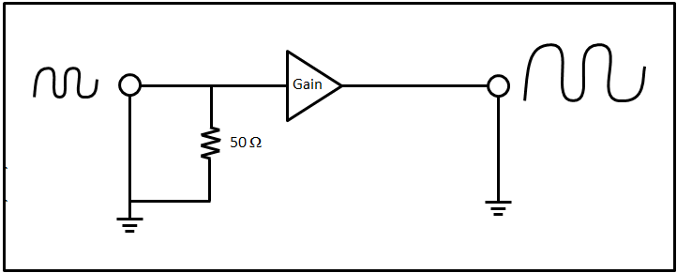

*Figure 4.3.1.1-1: Schematic of a current-sensitive preamplifier.*

**4.3.1.2 Parasitic-Capacitance Preamplifier**

The parasitic-capacitance preamplifier is for pulse-amplitude measurements or energy spectroscopy. Accompanied with high input impedance, the resulting current pulse from the photodetector merges on the combined parasitic capacitance at the detector output and preamplifier input. As this preamplifier’s gain is sensitive to small changes in the parasitic capacitance it is typically not used with semiconductor photodetectors but is used with photomultiplier tubes (PMT) and electron multipliers.

Accordingly, the combined capacitors result in a voltage pulse signal with amplitude similar to the total charge in the detector pulse and the rise time has the same length as the current pulse of the detector. A resistor is connected in parallel to the parasitic capacitance resulting in an exponential decay of the pulse. Additionally, a high impedance amplifier is place as a buffer to create low impedance for the output and is shown in figure 4.3.1.3-1.

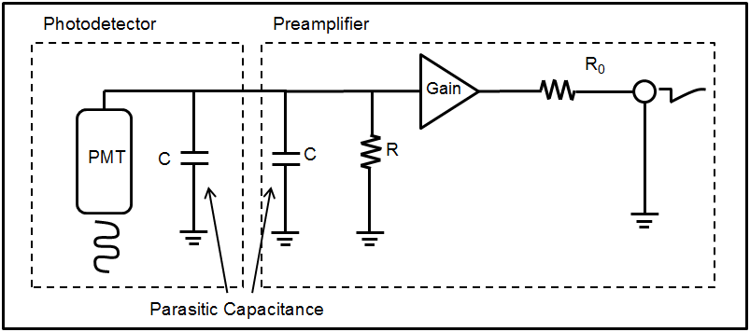

*Figure 4.3.1.3-1: Schematic of a parasitic-capacitance preamplifier.*

**4.3.1.3 Charge-Sensitive Preamplifier**

Typically used for energy spectroscopy, the charge-sensitive preamplifier uses a signal from a semiconductor photodetector as a charged quantity and is delivered as a short current pulse. The charge quantity and time of an event are the parameters measured by the charge-sensitive preamplifier. Unlike the parasitic-capacitance preamplifier, this preamplifiers gain is not sensitive to the photodetectors capacitance and a schematic is shown in figure 4.3.1.3-1. Additionally the output voltage can be calculated by, and the decay time constant by , where is the charge release of the detector, is the feedback capacitor, and is the feedback resistor.

The feedback resistor and the input capacitor are noise sources. Increasing the value of the feedback resistor will reduce noise but increase the decay time constant. Additionally, reducing the value of the feedback capacitor will keep the decay time constant but will affect the linearity of the preamplifier. The charge release of the detector can be calculated by , where E is the energy in MeV, e is the charge of an electron, is the conversion from MeV to eV, and is the required energy to produce an electron-hole pair in the detector. Furthermore, the output voltage can be expressed as and gain can be express as .

The noise in the charge-sensitive preamplifier can be measure by the full width at half maximum (FWHM) of the energy by a test pulse sent into the preamplifier input and is expressed as , where is the pulse amplitude, E is the energy, and is the root mean square voltage.

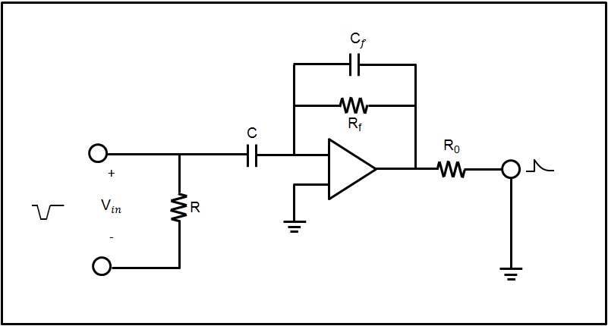

*Figure 4.3.1.3-1: Schematic of a charge-sensitive preamplifier.*

**4.3.2. Amplifiers**

Following the preamplifier is the main amplifier that processes and increases the amplitude of the input signal waveform without changing the other input signal parameters. An amplifier is typically described by the type of signal that is needed to be increased. Additionally, an amplifier typical has several parameters and includes gain, frequency response, and bandwidth, input impedance, output impedance, phase shift, and feedback.

Gain in an amplifier is simply the measurement of the amplification and is described as the ration of an output signal over the input signal. However, the gain is not the same at all frequencies resulting in a specific frequency response for each amplifier. Frequency response is a band of frequencies that amplifies the electrical signal within the band and excludes frequencies outside the band and an example is shown in Figure 4.3.2-1. Additionally, bandwidth is an important parameter that can be obtained from a frequency response curve. The bandwidth is the area between the lower cutoff frequency and upper cutoff frequency, and is useful gain for the amplifier.

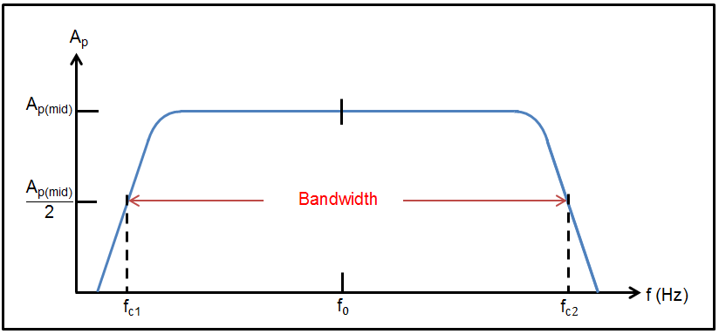

*Figure 4.3.2-1: Generic Frequency response curve and the resulting bandwidth. Where,, and are the center frequency, lower cutoff frequency, and upper cutoff frequency respectively. is the gain for either power, voltage, or a current.*

Input impedance is the same as resistance when there is no frequency and impedance is the opposite of an AC current flow. However when frequency is applied input impedance and resistance are not the same. Additionally, the input impedance is the effective impedance between the input terminals of an amplifier and is influenced by applied signal frequency, amplified gain, and feedback. The output impedance depends on the components connected to the amplifier output. An example is when a voltage signal falls this is because a current is drawn from the output terminals.

Phase shift, expressed in degrees, is a delay or advanced in the output signal with respect to the input signal. When electric components such as resistors, inductors, and capacitors are added to an amplifier circuit, typically this will result in a phase shift of one quarter output peak phase shift. Additionally, phase shift changes with frequency. Feedback occurs when the output signal goes back into the input and there are two types of feedbacks; positive feedback and negative feedback. Positive feedback increases the gain in the amplifier, where negative feedback reduces the gain in the amplifier.

**4.4. Filtering**

Filters are named after the frequencies they affect. Some common filters are passive, active, and digital filters. Passive filters only require the use of three electronic components; a resistor, an inductor, and a capacitor. Additionally, passive filters do not require an external power supply. However, active filters use a combination of passive and active components resulting in the need of an outside power source. Active filters are often accompanied with an active filter and the frequency is limited by the bandwidth. Digital filters are used to convert signals from analog to digital or vice versa.

For this senior design we will be using a bacic RC filter with a resistor and a capacitor. We will start off with a 1kΩ resistor and a 0.1μF capacitor.

**4.5 Receiver Design**

Figure 4.5-1 is what the receiver casing will look like. All the components will fit inside of the casing. The white circle in the front is where the incoming laser beam will enter and hit the photodiode. The circle in the back is where the power source wire will enter to supply the device with power, as well as the USB to serial adapter.

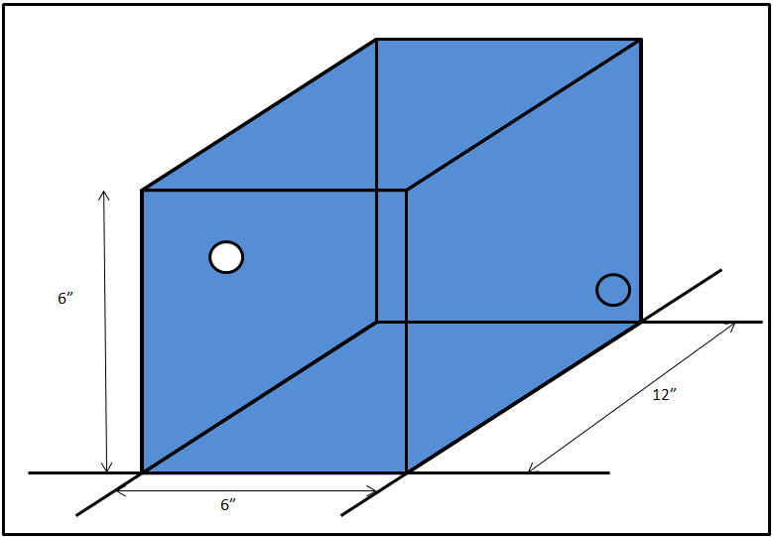

Figure 4.5-1: Drawing of the receiver and receiver component housing.

On the inside of the casing will contain the circuit boards for both the photodiode and the power systems for the photodiode and is shown in figure 4.5-2 and figure 4.5-3 is the complete and final design of the receiver housing with the receiver.

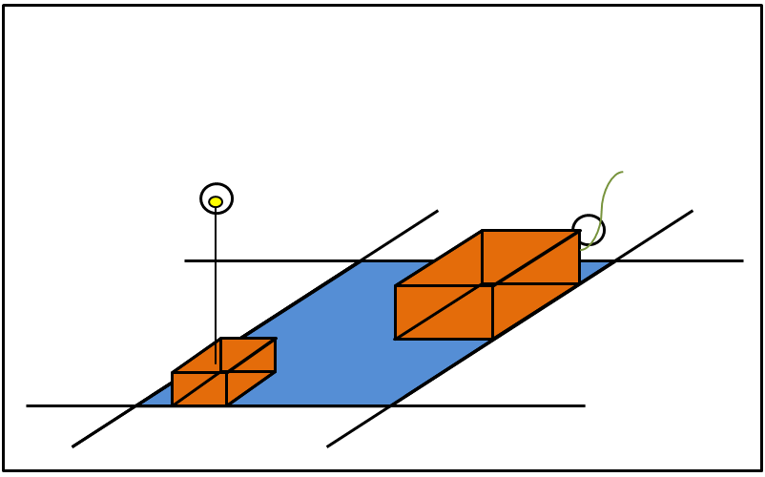

Figure 4.5-2: Photodiode circuit and the power circuit that is connected to both the computer and wall outlet.

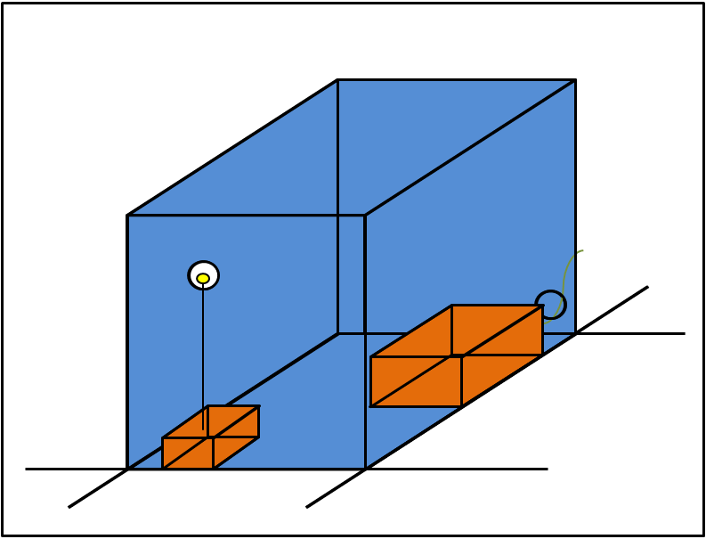

Figure 4.5-3: Final set up for the design of the receiver housing.

**5.0 Transmitter**

Transferring data by means of a laser calls for the use of a transmitter. In electronics a transmitter is an electrical device that generates and amplifies a carrier wave, modulates a signal derived from a source, and radiates the resulting signal to a receiver. In this project the transmitter will consist of a laser that will send a modulated signal to a receiver, printed circuit board (PCB) that will house the microcontroller and an voltage regulator circuit to power the transmitter. Before designing the PCB and voltage regulator circuit it is first necessary to determine what laser will be sending the signal. In order to do this some research was required. The following sections all explore important constraints when choosing which laser to use.

**5.1 Laser Types**

Before deciding on a type of laser to buy it is important to declare important requirements and specifications the laser must fulfil:

* The laser must emit light at 1.3 to 1.55µm. This wavelength range is both relatively safe and efficient. See the laser wavelength operations section as well as the laser frequencies section for a detailed explanation of the corresponding material.
* Laser tunability is not needed as wavelength division multiplexing will not be incorporated in this project. Standard bandwidths are then acceptable for this application.
* Avoiding optical feedback, or bandwidth dispersion, is crucial to how well the sensor can detect amplitudes.
* Power efficiency is not a large factor. The project will be drawing power from a serial connection from a computer.
* Let’s consider the different methods of producing a laser.

**5.1.1 Semiconductor Lasers:**

Semiconductors have revolutionized the laser industry. By controlling the flow of electrons to emit light, semiconductor lasers have become a cheap and compact-size laser. Semiconductor lasers also A semiconductor laser can now be optimized to fit desirable attributes. The following sections are different types of semiconductor diode lasers:

**5.1.1.1 Fabry-Perot Diode Lasers**

One of the most common types of semiconductor laser, the Fabry-Perot diode laser will function, but is not optimized. This laser type can be compared to an LED pumping in a resonator cavity. Due to the construction of the diode laser setup it produces a wider spectral width than other alternative lasers. In order for an optical sensor to receive the data correctly the beam must be of a coherent nature, which Fabry-Perot diode lasers typically are not.

**5.1.1.2 Heterostructure Diode Lasers**

A heterostructure diode laser consists of multiple heterojunctions. A heterojunction comprises of two different lattice matched crystalline semiconductor materials containing different bandgap energy levels that, when matched together, produce electron movement and light is then emitted.

**5.1.1.3 Quantum Diode Lasers**

There are three types of quantum diode lasers:

1. Quantum well lasers
2. Quantum line lasers
3. Quantum dot lasers

Quantum diode lasers are atomic in nature, yet exhibit the same desired quality that semiconductors. Quantum diode lasers specialize in short wavelengths and were designed to have more control over the absorbance and emission wavelengths. This is accomplished by altering the energy levels, through quantization. Overall, this laser type is not the most efficient for our applications. A laser that has maximum intensity is desired more than a broad range of wavelengths to choose from. Quantum diode lasers are more expensive than more traditional semiconductor diode lasers.

**5.1.1.4 Distributed Feedback Diode Lasers**

Distributed feedback diode lasers are optical fiber lasers that utilize a diffraction grating to select and filter a particular wavelength to be emitted. Having a lower bandwidth is desirable to eliminate wavelength dispersion. By eliminating wavelength dispersion the distributed feedback laser can send more precise pulses at different intensity values. The more intensity levels that can be produced the higher order number systems can be used. This is exactly what desired for this project is. Optical fiber lasers, in general are small packages that are easy to incorporate into a circuit. Distributed feedback diode lasers are a strong candidate for this project requirements and specifications.

**5.1.1.5 Vertical Cavity Surface Emitting Laser (VCSEL)**

VCSEL’s incorporate distributed Bragg reflector mirrors and quantum wells to achieve lasing capabilities. For this project VCSELs are appealing. VCSELs are more compatible with fiber coupling, and easy for manufactures to fabricate so cost will be reduced. Lower power is the only disadvantage to this type of laser.

**5.1.2 Gas Lasers**

One of the most widely used laser types; a gas laser utilizes different types of gasses as gain material. When a current is applied through this gain material, electrons are excited to higher energy states then, upon returning back to its lower energy state emits light in a coherent manner. Gas lasers are effective but are very large, when compared with other laser types, such as semiconductor lasers. Gas lasers also require a lot of energy to operate and are typically not cheap. Gas lasers do not have the ability to control intensity values and pulsing for data transfer easily. Therefore, gas lasers are not a viable option for this project.

**5.1.3 Chemical Lasers**

Chemical lasers utilize the energy from chemical reactions to produce very high continuous wave output intensity values. To achieve similar power levels other laser types need to be pulsed. This laser type is, however, typically a tool used in industry for cutting, or used in research. Chemical lasers cannot be pulsed easily and intensity values cannot be altered. This laser is not appropriate for data transfer.

**5.1.4 Solid-State Lasers**

Solid-State lasers have many military applications as a laser that produces high output powers. As mentioned with other laser types size is again an issue as well as the amount of energy required to operate the laser. The laser also cannot be simply controlled by a driver circuit to be pulsed which makes it an unlikely candidate for out project.

**5.1.5 Laser Packaging**

For the purposes of this project as well as time constraints stand-alone semiconductor laser are not going to be a viable option. This limits the project to package laser systems. There are many different types of packaging options when dealing with lasers. In Telecom laser applications there are three major types of packing options: Butterfly, Boxed TOSA MSA, and TO-Can TOSA. Butterfly is the standard format for optical Telecom transmissions. A butterfly package typically contains 14 pins and a Thermo Electric Cooler (TEC). This method of regulating the temperature is required to ensure a more stable power output and minimizing the beam divergence of the outgoing laser beam. Butterfly packaging is typically used for bit rates up to 10Gbit/s. A boxed TOSA MSA is a standard used with bit rates up to 100Gbit/s. This type of packaging was designed to be a miniature version of the butterfly packaging. This left less room for the TEC. Smaller TECs were designed which causes the price of this packaging to be higher than the more universal butterfly package.. The last packaging option is TO-Can TOSA. This package option is a compromise between the butterfly and boxed TOSA MSA configurations. It is a cheap and compact package that is projected to be the new standard. Any of these three packaging types can be used in this project.

**5.1.6 Product Comparison**

We have successfully narrowed down the possible laser types to quantum well lasers, VCSEL, and Distributed Feedback Diode lasers. Table 5.1.6-1, split up by laser type and structure, is a list of different lasers currently on the market.

|  |  |  |  |  |  |  |
| --- | --- | --- | --- | --- | --- | --- |
| **Table 5.1.6-1 Laser Comparison** | | | | | | |
|  | **Wavelength Range (nm)** | **Operating Voltage (V)** | **Threshold Current**  **(mA)** | **Output Power CW (mW)** | **Pulse Width**  **(ns)** | **Price**  **$** |
| **Diode Only Quantum Well Laser** | | | | | | |
| **Panasonic LNCT28PF01WW** | 656-665 | 2.4 | 50 | 100 | 30 | 15.62 |
| **Panasonic LNCT22PK01WW** | 777-791 | 2.5 | 45 | 200 | 100 | 15.62 |
| **Diode Only Vertical Cavity Surface Emitting Laser** | | | | | | |
| **TT Electronics OPV300** | 860 | 2.2 | 3 | 1.5 | .2 | 14.65 |
| **TT Electronics OPV314AT** | 860 | 2.2 | 3 | .6 | .210 | 20.50 |
| **Pigtail Package Quantum Well Laser** | | | | | | |
| **US-Lasers MM850-0** | 840-860 | 2.4 | 20 | 5 | - | 76.0 |
| **Renesas NX7338BF-AA** | 1310 | 2.5 | 20 | 10 | 4 | 266.0 |
| **Renesas NX7538BF-AA** | 1550 | 2.5 | 45 | 10 | 4 | 285.95 |
| **14 Pin Butterfly Package Quantum Well Laser** | | | | | | |
| **Mitsubishi FU-68SDF-V802MxxB** | 1550 | 1.8 | 10 | 6 | .150 | 148.50 |

After analysis of many lasers that can be purchased in the market this project will be utilizing a quantum well laser to transmit its data to the receiver. This laser type is more expense than other types but, it allows for higher maximum intensities and they are packaged in pigtail configurations. This allows the laser to be easily integrated into our project design.

This project places emphasis on the pulse width that a laser can be modulated to, as well as the cost. Stand-alone laser diodes are cheaper and have more desirable specifications, such as pulse width, but entire configurations have a photoresistor and can more easily be incorporated to a design. The photoresistor serves to regulate the output power of the laser beam, which is important when choosing the appropriate receiver photoresistor.

**5.2 Analog vs Digital Communication**

In an age where digital communication is dominating over analog some applications still require analog signals for broadcasting a signal. Services such as television, telephones, and radio still utilize this archaic communication type. Our group is going to design an electronic device that is required to have the ability to transmit videos and audio clips, as well as other forms of data. It is important to consider both types of communication with an unbiased opinion. Highlights, or advantages and disadvantages, of both methods of communication are summarized in Table 5.2-1.

|  |  |
| --- | --- |
| **Table 5.2-1: Analog vs. Digital Communications** | |
| **Digital Communication** | **Analog Communication** |
| Signal that transmits a square waveform at discrete time intervals. | Signal that transmits information in a continuous sinusoidal waveform |
| Can be implemented in Computing and data transfer easier | Easier to transmit audio or video signals |
| Hardware records bits of data at discrete clock intervals | Hardware records entire signal |
| Less susceptible to noise interference | Greatly affected by outside noise interference |

The project seeks to transmit data. In analog communication there is much more noise. This translates to loss of bits of data. For the purposes of this project digital communication is the most efficient method of data transfer. Loss of bits still occurs, but there are coding methods of ensuring minimal losses occur.

**5.3 Laser Modulation Types**

In order for a specific signal to be transmitted and received it needs to undergo modulation. Modulation is a way a transmitted signal is manipulated in order for a receiver to distinguish between different bits of information. All the methods to modulating a laser can be grouped into two categories:

1. Internal/Direct Modulation- the manipulation of a laser signals amplitude by varying either the supplied voltage or current to the laser.
2. External Modulation- the manipulation of a laser signals phase, or amplitude, by integrating an electro-optic device that splits the incoming laser signal into two beams that are fashioned to constructively and destructively interfere.
3. Wave Division Multiplexing- the manipulation of a laser signals frequencies by diving a laser signal into multiple frequencies with finite bandwidths assigned with bit information.

**5.3.1 Internal/Direct Modulation**

Direct modulation is the earliest form of modulation in analog communications. Almost every packaged laser system can be directly modulated by just altering the voltage or current. All three types of modulation mentioned in the modulation section utilize amplitude modulation to modulate the laser power intensity. When dealing with data rates of 2.5Gbit/s to 10Gbit/s direct modulation can be used to transmit data. When designing a system using direct modulation three different types of modulation can be used.

1. Small Signal Modulation – Small sinusoidal variations in the supplied current. Can support speeds of between 1Gbit/s to around 20Gbit/s, but due to the continuous nature of the analog signal it is an unreliable signal for data transfer.
2. Large Signal Modulation – Relatively large square pulse that causes the laser to dip below and above its lasing threshold. This leads to a very slow Turn-on delay time. Typical lasing turn on time is 10ns, which is not small enough to support Gbit/s frequencies.
3. Pulse Code Modulation – Is a square pulse that is configured to modulate just above lasing threshold. This eliminates the turn-on delay of the laser and achieves a stable signal that has a bit rate in the desired Gbit/s regime.

Pulse code modulation is the preferred direct modulation method for laser data transfer. It is a simple and fundamental modulation method. Pulse code modulation is easy to analyze an laser pigtail packaging is designed to be modulated directly.

**5.3.2 External Modulation**

External modulation utilizes the constructive/destructive interference of laser beams to modulate the intensity, or polarization, of the laser beam. To achieve a bit rate beyond small signal modulation an external modulator, or electro-optic modulator may be configured. This special type of modulation exploits phase modulation by sending an incident laser beam through a waveguide that splits the beam up into two beams of equal intensity. Then one waveguide will shift the phase of the second beam 90 degrees, which when the beams combine again they cancel and produce a zero. Ones will be produced with no phase shift. Even though this modulation type produces some of the fastest bit rates it is not feasible to use in this project. Incorporating an external modulator would require a great deal of space and optical precision. Packaged laser systems available can be made to phase modulate, but traditionally this modulation type is more difficult to incorporate to integrated systems without the system becoming large. Due to our size constraint we cannot use this method. Due to time constraints and limited overall system packaging this modulation type is not efficient.

**5.3.3 Wave Division Multiplexing**

Wave division multiplexing is a method where the variation in frequency can be picked up by a sensing device. If a broad spectrum laser beam source was chosen for the project then the beam could be transmitted through a grating that only allows certain frequencies of light to pass an discrete time intervals. This shift can then be picked up as a change in wavelength and be associated with a digital value for signal transmission. Wave division multiplexing is an important and effective discovery in communication that allows a single signal to have many bits of information. The limit of the system is how narrow the bandwidth can be transmitted and received. The cost to include this method of data transfer is far too high and due to time restrictions this effective communication tool cannot be used in this project.

**5.3.4 Modulation Method to be Employed**

After analyzing the three most common methods of laser modulation the group determined that direct modulation will be the most suitable means to transmit a signal. We decided on this largely due to the simplicity of direct modulation in digital communications. The laser chosen for the project has already been designed to be directly modulated, which will allow the group to focus efforts on other important components to the project. Direct modulation will also be more cost efficient as no additional components will need to be incorporated to the design. The next step in the design process is to consider the different keying methods to direct modulation.

**5.3.5 Keying Methods for Direct Modulation**

Amplitude modulation had been decided to be the primary form of modulation for the laser. There are many different amplitude modulation methods, two of which are: Amplitude Shift Keying (ASK) and On-Off Keying (OOK). Amplitude shift keying is a type of amplitude modulation that assigns bit values to discrete amplitude levels. When the analog signal is at its maximum intensity the receiver will register a one. Conversely, when the signal is at a low intensity, designated by the receiver to read, a zero will be registered. More bits can be added to this keying type by assigning signal intensity values to numbers, creating quantization levels. The limit to this is the amount of signal noise the laser transmits and detector introduces to the signal upon receiving the signal. On-Off Keying is similar to Amplitude shift keying expect registered value of zero occurs when there is an absence of signal, or when only a noise level is detected. This leads to a greater number of quantization levels, but On-Off keying fundamentally causes the laser to fall below threshold. If the laser falls below threshold then lasing ceases to occur. To transmit the signal again the laser would require additional time to achieve lasing, which is not desirable for the purposes of this project. Figure 5.3.5-1 compares a digital binary data signal to the ASK, OOK, and FSK keying methods:

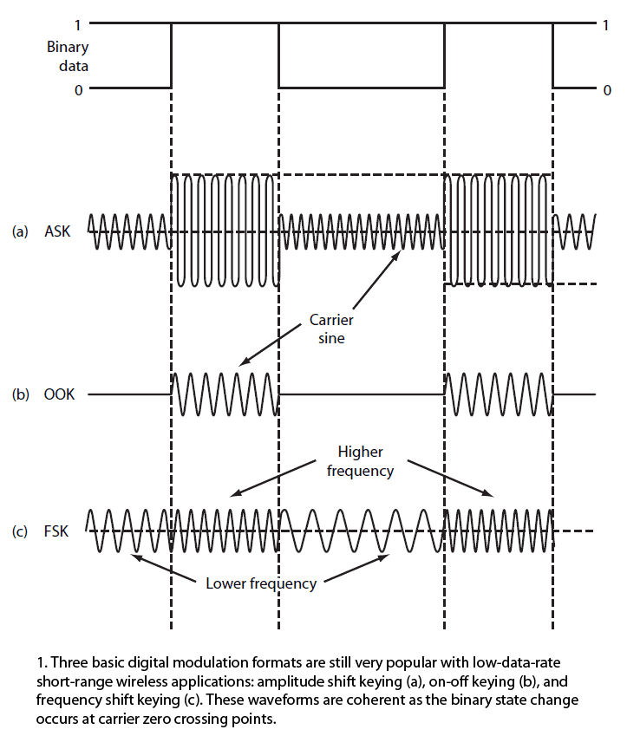

*Figure 5.3.5-1* courtesy of Lou Freszel

This project will be incorporating amplitude shift keying as the means to transmit data, through air, using a laser. The group will be upholding the product specification of having the capability of transmitting up to 8 bits of data at once. This will increase the amount of data that can be sent at a time. The limiting factor to the quantization level, or number of bits, that can be sent is the amount of noise a system has. The following topic offers insight to understanding signal noise.

**5.3.6 Signal Noise**

Noise in Digital communications is an important property to mitigate. Figure 5.3.6-1 is a reading of a transmitted signal in an optical fiber communication system, taken by an oscilloscope. The input square waveform of ones and zeros is modulated, transmitted using a laser at 1550nm through a 2km fiber optic cable received by a photodetector and demodulated to form the purple signal. The output purple signal contains a noise level.

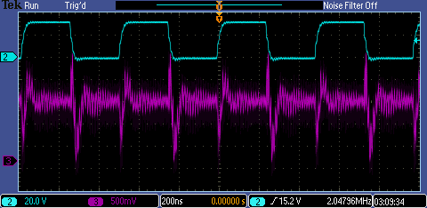

*Figure 5.3.6-1*

**5.3.6.1 How Noise is introduced to an Optical System**

In order to prevent noise we must understand where it comes from. Noise in an optical system comes from the photodetector, electronics design, and shot noise of the incoming light itself. Usually thermal noise from electronic design is the dominant noise. Keeping the electronics as cool as possible will be a priority. Prototype testing will provide the group with the potential feedback required to adjust the design accordingly. If thermal noise is an issue preventions such as adding a fan to the rear of the transmitter housing, heat sinks to help pull heat off vital components. The transmitter housing can also be constructed out of aluminum to help dissipate heat. All options will be considered when designing the most efficient transmitter.

**5.3.6.2 Methods of Mitigating Noise**

Noise in an analog signal can only be prevented so much. There are components that can be added to reduce noise, or allow for the signal bit values to be readable by the photodetector. Some common components in a telecom communication system are:

1. Amplifier-takes in a received signal and increases the entire waveform at every location and then transmits the enlarged signal. This is somewhat effective when being able to discern between quantization levels but eventually noise levels within the signal will be greater than some of the lower bits, causing a loss of data.
2. Repeaters-takes in a noisy signal just before it becomes unreadable and resends a new signal copied from the original signal. This requires an entirely new transmitter, which is more components and will exceed the project budget.

These options are attractive but costly. In order to remain within budget this project will not contain repeaters or amplifiers.

**5.3.7 Analyzing Bit Error Rate**

The objective of transmitting any form of data is to preserve the bits being transmitted in such a way that the receiver can detect exactly what that data was that was sent. Hard work in involved in order to preserve these bits but naturally some bits will not be read correctly. This misrepresentation of bits can be quantized into a number called the bit error rate (BER). Understanding how the BER can help in designing an efficient data transfer system. The following describes what BER is and how to use it.

**5.3.7.1 Bit Error Rate**

In an ideal data communication system the user would like to see zero bits dropped but it is inevitable, especially when air is used as a medium of travel, that some bits will be lost. These bits can be summarized into a BER. The BER is a measure of the number of incorrectly transmitted bits per unit time. Incorrectly transmitted bits can occur from a process that alters the sending signal to something undesired. Some of the most common reasons that causes a BER is noise, interference, distortion, and bit synchronization errors. Mitigating these reasons will be key to an proficient telecommunication system. The group will be utilizing eye diagrams to analyze potential signal deficiencies. The subsequent topic describes eye diagrams.

**5.3.7.2 Eye Diagrams**

One of the most effective tools in analyzing signals for noise, interference, and other forms of signal disruptions is eye diagrams. An eye diagram overlaps multiple bit strings on top of one another to form a graph that looks similar to DNA. Figure 5.3.7.2-1 is a digital signal that would be detected by a photdetector. To create an eye diagram from the signal first split up the signal into equal strings according to bits sent. The minimum number of bits it takes to create an eye diagram is 3 bits. The signal in Figure 5.3.7.2-1 contains 24 bits so the signal was split into four 6 bit strings.

**Series 1**

*Figure 5.3.7.2-1*

Then overlap the four strings using the same coordinate system. Figure 5.3.7.2-2 is a graph of the four 6 bit strings overlapping each other. When enough strings are overlapping each other the eye diagram is created. The center of the diagram is the ‘Eye’.

**Eye of the Diagram**

*Figure 5.3.7.2-2*

Eye diagrams contain a myriad of information on signal integrity such as rise and fall times of signal pulses, jitter, distortion and signal to noise. Figure 5.3.7.2-3 is data extracted from an oscilloscope reading of a digital communication system using a 1550nm laser.

**Fall Time**

**Rise Time**

*Figure 5.3.7.2-3*

Upon analysis of the eye diagram some deduction can be made. The peak to peak distortions on both the high and low bit levels keep the eye from being open. With no clear separation between high and low bits potential error can occur. Jitter is low, and due to the intersection of the jitter points being above than the center line means that the fall time is slower than the rise time. All these deductions can allow the user to focus on the limiting factors of the signal to minimize the BER. The following topic will explain laser safety standards and why they are important.

**5.4 Laser Safety Standards**

Safety is a big concern when choosing the type of laser that will be implemented to any design. Frequencies in the visible spectrum can be more dangerous to the human eye. This is due to the human eye having characteristics that focuses visible light between 300 to 650nm directly into the retina, causing more damage with lower power outputs. Therefore, this project will be utilizing frequencies beyond 1µm. These frequencies are absorbed by the eyes cornea and lens, allowing for greater output powers. Frequencies beyond 1µm can still be dangerous to the eye and skin so for the applications of this project we will limit the power to 5mW. Figures 5.4-1, 5.4-2, and 5.4-3 all show the consequences of receiving a direct laser beam to the eye:

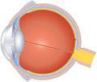

Figure 5.3-1, to the right, is the standard human eye when introduced to optical frequencies (350nm-700nm). The eye focuses these frequencies to a focal point directly onto the retina. At the focal point the intensity of the incoming light is at its maximum.

*Figure 5.4-1*



Figure5.3-2, to the right, is the standard human eye when introduced to near IR radiation (700nm-1400nm). The eye focuses these frequencies close to, but not directly onto the retina.

*Figure 5.4-2*



Figure 5.3-3, to the right, is the standard eye when introduced to Mid-range IR (1400nm-10000nm). Mid-range frequencies are absorbed by the Iris and Cornea. No focal point is present within the eye laser intensities before damage is done.

*Figure 5.4-3*

When comparing Figure 5.4-1 and Figure 5.4-3 above Mid-range IR is safer than optical wavelengths. With enough power even Mid-range IR can be damaging to the iris and cornea. Damage done to the eye in this manor is called ‘flash burning’. In order to avoid this damage we will adhere to laser safety standards in place by the Center for Devices and Radiological Health. This standard can be understood in the following section.

**5.4.1 Laser Classes**

The Center for Devices and Radiological Health (CDRH) was tasked with determining a class system for the performance safety for all lasers within the United States. The result is a regulation known as the Federal Laser Product Performance Standard (FLPPS) and can be found by searching the address 21CFR sub-chapter parts 1040.10 and 1040.11. This regulation divides all lasers into five classes: Class 1, 2, 3a, 3b, and 4. This Standard is more commonly referred to as ANSI-Z136.1 and is generally regarded as the industry standard. Table 5.4.1-1 describes each laser classification:

|  |  |
| --- | --- |
| **Table 5.4.1-1 ANSI-Z136.1 Laser Classifications** | |
| **Class 1** | Any laser or laser system containing a laser that cannot emit laser radiation at levels that are known to cause eye or skin injury during normal operation. This does not apply to service periods requiring access to Class 1 enclosures containing higher class lasers. |
| **Class 2** | Visible lasers considered incapable of emitting laser radiation at levels that are known to cause skin or eye injury within the time period of the human eye aversion response (0.25 seconds). |
| **Class 3a** | Lasers similar to Class 2 with the exception that collecting optics cannot be used to directly view the beam |
| **Class 3b** | Medium powered lasers (visible or invisible regions) that present a potential eye hazard for intrabeam (direct) or specular (mirror-like) conditions. Class 3b lasers do not present a diffuse (scatter) hazard or significant skin hazard except for higher powered 3b lasers operating at certain wavelength regions. |
| **Class 4** | High powered lasers (visible or invisible) considered to present potential acute hazard to the eye and skin for both direct (intrabeam) and scatter (diffused) conditions. Also have potential hazard considerations for fire (ignition) and byproduct emissions from target or process materials. |

This class standard is what our group will use to determine the appropriate laser. For this project we will be designing a Class 2 laser system. Class 2 laser systems will offer the highest intensity value, while keeping the project safe for demonstration.

**5.4.2 Laser Wavelength Operations**

In telecom applications coherent laser light traditionally travels through fiber optic cables with glass cores. When studying different wavelengths that pass through the fiber cable wavelength bands that had lower loss characteristics was discovered. Below is an illustration of loss in fiber optic cables:

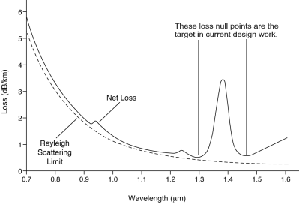

*Figure 1: Pending approval courtesy of Understanding Data Communications, 6th Edition by Gilbert Held.*

This project is using air as a medium instead of glass. The important null points of the graph disappear and the overall loss increases from dB/km to dB/m. The longer wavelengths, such as IR lasers, will then be more suitable for transmitting data through the air. IR lasers can penetrate through atmospheric conditions better than visible light.

**5.5 Transmitter Design**

In order to meet product specifications it was decided that a 3 dimensional model of the transmitter and transmitter housing was to be constructed. The transmitter model is pictured in Figures 5.5-1, 5.5-2 and 5.5-3 and was designed using a free open source drafting program called FreeCAD. This model gives the group an idea of what the final product will look like. Figure 5.5-1 show a front view of the transmitter. The laser will be attached perpendicular to the front face of the transmitter housing at location a. This will simplify aligning the laser with the receiving photodiode. Under the transmitter housing will be four adjustable feet on each corner of the housing. They will be constructed from nuts, fastened to the bottom face of the transmitter housing, and bolts. Rubber will be glued to the bottom of the bolt heads to avoid the alignment complications of slipping and sliding of the transmitter. The bolts can then vary each edge of the transmitter, which will aid in the aligning process. The entire transmitter housing will be constructed out of a fully transparent Plexiglas. In order to avoid overheating of the circuitry and laser packaging within the transmitter housing the left, right, rear and bottom faces of the transmitter housing will have machined louvers cut into them. Louvers on the top face would be ideal, due to the lighter density hot air rising over the heavy density cool air, but gravity would cause more detrimental materials to fall inside such as water. The left, right and rear face louvers will be vertical and the bottom face louvers will run down the width of the transmitter housing. The vertical louvers around the transmitter housing will allow hot air to escape and the bottom louvers will allow cool air to enter the housing. These louvers will aid in heat dissipation, keeping all circuitry and laser packaging from overheating. The top of the transmitter housing will also be placed on hinges. This will allow the group to access the interior components for any reason.

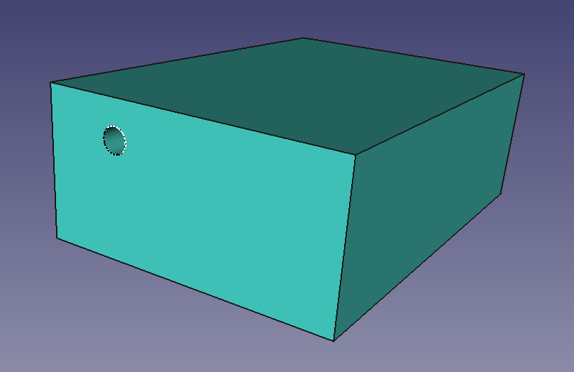

**4 in**

**12 in**

**6 in**

a

*Figure 5.5-1*

Figure 5.5-2 is a 3 dimensional model of the back of the transmitter housing. The power cable, labeled b, will allow input power from a 120V AC wall outlet. This power will enter directly into the AC to DC converter circuit board that will also regulate the DC voltage to the required input voltage of the PCB microcontroller. The voltage will then be divided to each component according to their required input voltages. The input data from the computer will enter the transmitter housing, labeled c, and connect directly to the PCB microcontroller. This data will be the input signal that is transmitted to the receiver. There will be a manual power switch on the rear of the transmitter housing at position d in Figure 5.5-2. The power switch will control the voltage regulator circuit and, therefore, the PCB and laser.

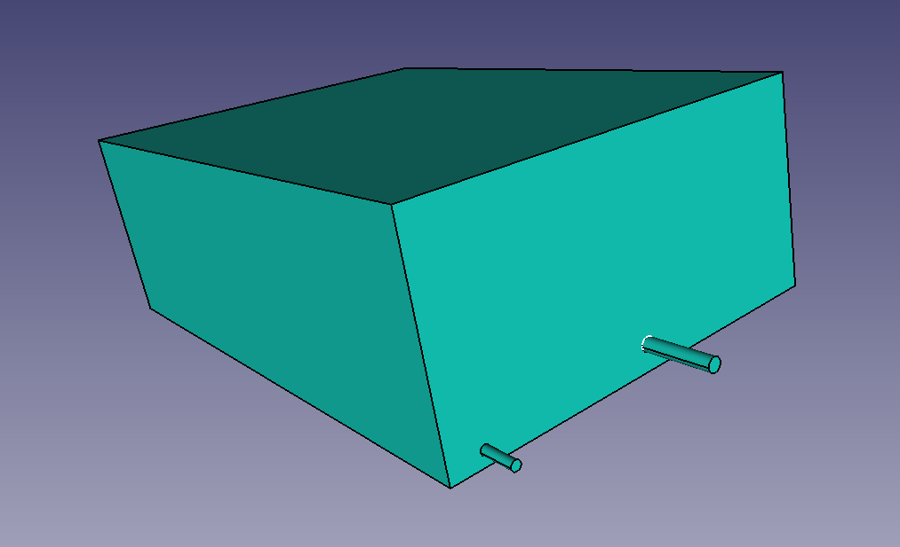

d

c

b

*Figure 5.5-2*

Figure 5.5-3 is a look inside of the transmitter housing. The PCB microcontroller, labeled e, will be located on the left side of the picture and the voltage regulator circuit, labeled f, will be toward the rear of the tranmitter housing. The transmitter house will keep the PCB and voltage regulator circuit as far away as possible to mitigate any thermal exchange from each of the respective crcuits. Location g, in Figure 5.5-3, is where the laser packaging will reside. The fiber will be coiled up in a circular loop and fastened down with ties to aviod any damage to the laser package. It is also important to note that the group will be utalizing the PON connector on the terminating end of the flylead of the butterfly package to establish a perpindicular joining to the front of the transmitter housing. A female end to the PON connector will be attached to label a of Figure 5.5-1. This will allow the group of remove the laser when desired.

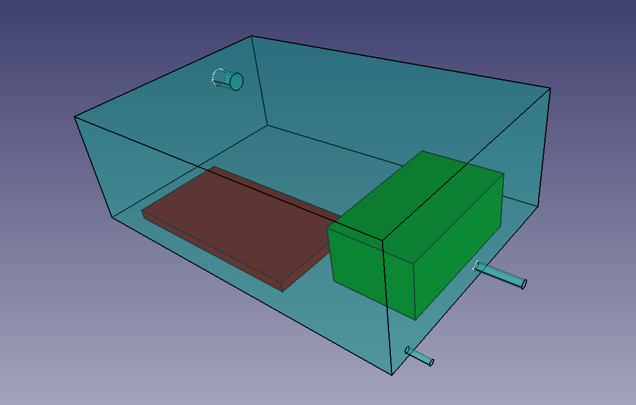

g

f

e

*Figure 5.5-3*

**6.0 Power Electronics**

Power electronics uses a combination of different electronic components to control and convert the input electric power into a processed power output. These power systems use two types of current flow, either DC (Direct Current) or AC (Alternating Current). Additionally, there are several categories of power electric converters, only four will be discussed and are the Rectifier, Inverter, and Voltage Regulator and DC Chopper.

**6.1 AC Power**

Alternating Current (AC) is an electric current, can also be measured as a voltage level, which can flow in the forward and backward direction. This form of electricity is typically transported by powerlines to residential areas as a sine waveform and is a time varying quantity. The major advantage AC has over DC is the ability for AC to be increased or decreased voltage with the assistance of a transformer resulting in higher voltage transmission through powerlines. High voltages also lead to an increase in insulation which leads to hazardous safety handling.

**6.2 DC Power**

Discovered by Thomas Edison, Direct Current (DC) power is known as the first form of electrical power transmission. DC is an electric current which flows in one direction and can be used to charge or supply power; examples include batteries and solar cells. Although AC is the preferred transmission of a current, DC is typically used for long distance such as undersea cables. Additionally, the voltage or current across a DC source can change as long as the flow does not.

**6.3 Rectifiers (AC to DC)**

A rectifier is an electrical device that converts AC to DC. Additionally, there are many different types of rectifying devices but semiconductor diodes and thyristors are commonly used. The semiconductor diode is known as an uncontrolled rectifier, and the thyristors is known as controlled rectifiers both reflect their dc output. Rectification can be accomplished by using a half wave or a full wave rectifying circuit. Additionally, the common types of rectifiers include: Single-Phase half wave, full wave, and bridge rectifiers and three-phase full wave and bridge rectifiers.

**6.3.1 AC to DC Rectifier for Transmitter Circuit**

The rectifier is where the entire transmitter assembly will be getting its power from. The designers of the LDT project have decided to use currently available AC to DC adapters to power both the transmitter and receiver. These adapters will be responsible for rectifying 120VAC to a useable 9V DC source at 1A. The adapter will then be connected directly to the microcontroller. The following section discusses different connectors this project can utilize.

**6.3.2 AC to DC Rectifier Connector Options**

At first the design team of the LDT project considered connecting the AC to DC rectifier directly to the microcontroller input VCC and Ground pins. This would achieve sending power to the transmitter circuit, but can make the prototype testing of the transmitter circuit difficult. To make the LDT project more robust and mobile the designers have decided to use a pin connector. This will also make power adapters interchangeable in case the AC to DC rectifier breaks. If troubleshooting is required being able to interchange AC to DC rectifier wall adapters will be beneficial as well. There are a variety of connecters for low power output. Table 6.3.2-1 displays a few of the most popular connector types on the market:

|  |  |
| --- | --- |
| **Table 6.3.2-1 Common AC to DC Rectifier Connector Types** | |
| **DIN Plug** | Deutsche Industry Norm Standard not a popular connector for power supply. |
| **3-Pin and 4 Pin DC Plug** | Limit is up to 20V at 7.5A. This connecter is also known as a power connector. |
| **Concentric Barrel Plug or Coaxial Power Connector** | Wide range of voltage and current capabilities. |

Common adapters use the coaxial power connectors. These can be found charging notebooks, powering Wi-Fi routers and other various low voltage applications. Table 6.3.2-2 is a list of five different size coaxial power connectors, and their capabilities:

|  |  |
| --- | --- |
| **Table 6.3.2-2 Coaxial Power Connector Sizes** | |
| **EIAJ-01** | 0-3.15V |
| **EIAJ-02** | 3.15-6.3V |
| **EIAJ-03** | 6.3-10.5V |
| **EIAJ-04** | 10.5-13.5V |
| **EIAJ-05** | 13.5-18V |

Based off the research the LDT project can utilize the EIAJ-01 coaxial power connecter. This connecter size will provide the both the transmitter and receiver with up to 10.5V, which is more than the designed circuits require to be powered. The following section will research different AC to DC rectifier adapters currently available on the market. One will then be chosen to be used for both the transmitter and receiver circuits.

**6.3.3 Product Comparison AC to DC Rectifier Adapter**

After determining the plug type the group researched universal AC to DC adapters that had, or was compatible with the EIAJ-03 plug. Table 6.3.3-1 is a product comparison of three universal AC to DC adapters from different vendors:

|  |  |  |  |  |  |
| --- | --- | --- | --- | --- | --- |
| **Table 6.3.3-1 Product Comparison Universal AC to DC Adapters** | | | | | |
|  | **Supply Current** | **Seller** | **Supply Voltage** | **Number of Adapters** | **Cost** |
| **Original Power Powerline** | 1300mA | Walmart | 3-12V | 7 Plugs | $11.65 |
| **Velleman PSSMV1USA** | 1500mA Max | Amazon | 3-12V | 8 Plugs | $14.99 |
| **Enercell** | 1000mA | Radioshack | 3-12V | 0 Plugs | $19.99 |

Radioshack has always been known for quality electronics. The Enercell would be a more dependable choice for the project, but the adapter lacks the different connecter choices. The Velleman adapter found on amazon is more suitable than the Enercell adapter. The Velleman has multiple adapters to choose from, including the desired adapter, but the product would have to be shipped. The group can avoid shipping cost by purchasing the Original Power Powerline at Walmart. If the adapter is not available in the store it can be shipped at walmarts expense, and it contains 7 different connecters including the desired connecter. Therefore, the designers will incorporate the Original Power Powerline AC to DC adapter to power the transmitter and receiver box.

**6.4 Inverters (DC to AC)**

An inverter is the opposite of the rectifier, and converts DC to AC. However the input DC voltage or current can come from a rectifier, this is known as a dc link converter. The resulting output AC frequency is adjustable by varying the inverter device frequency. Additionally, the two dominant output wave forms are the square and sine wave. The square wave form is simple and useful, and the sine waveform is superimposed. Inverters are the first process in an AC system and there is three different types, the voltage source, current source, and resonant inverter.

**6.5 AC to AC converters**

An AC to AC converter changes the input ac signal into a different ac voltage, frequency, phase, or shape depending on what is desired. Typically a these converters are more efficient than a dc link but often involves a greater amount of semiconductor switching devices. There are three types of AC to AC converts and include the AC voltage regulator, direct frequency converter, and DC link converter. However the ac voltage regulator is the simplest and changes the ac voltage without affecting the frequency.

The ac voltage regulators are either a single phase or a three phase, and typically for higher power loads the three phase voltage regulator is used. However if frequency is to be changed the direct frequency converter is used and converts an input ac frequency signal to a different frequency. The most common direct frequency converters are cycloconverters and matrix frequency converters, and benefit from not containing energy storage within the circuit. DC link converters have many application uses as they can convert a wide range of power, however at large power levels the performance will be affected.

**6.6. DC to DC converters**

The DC to DC converters changes the magnitude of the input dc signal and is considered linear and switching converters. A linear converter typically deals with low power for analog, audio, and interface circuits. The more commonly used switching converter takes the input dc signal and chops it up then averages the current as a percentage. DC to DC converters are categorized as either DC voltage regulator, step down chopper, step up chopper, and universal chopper.

**6.7 USB to Serial Converter**

For the power source of this senior design project, a USB to serial converter will be utilized. However for optimal transmission the USB to serial converter must have several requirements: Processing chip, serial driver chip, output power, static protection, and TX and RX activity.

**6.7.1 Processing Chip**

The processing chip required should be either FTDI or Silabs as they are known to be very reliable. Typically for FTDI processing chip the FT IC series is used and is known as USB slave converters. However, Silicon Labs offers free samples and will be using a Silabs processing chip. Below is figure 6.7.1-1 of 32-bit USB capable microcontrollers offered by Silabs. Silicon labs processing chips are preferred because they are used with a large quantity of devices and equipment. Additionally they are stable and compatible with Windows, Mac, and even Linux.

|  |  |  |  |  |
| --- | --- | --- | --- | --- |
| ***Silabs*** | Happy Gecko | Leopard Gecko | Giant Gecko | Wonder Gecko |
| Core | ARM Cortex MO+ | ARM Cortex M3 | Arm Cortex M3 | Arm Cortex M4 |
| Speed (MHz) | 25 | 48 | 48 | 48 |
| Flash (kB) | 32-64 | 64-256 | 512-1024 | 64-256 |
| Ram (kB) | 8 | 32 | 128 | 32 |
| Digital I/O | 35 | 93 | 93 | 93 |
| UART | 1 | 2/4 | 2/4 | 2/4 |
| USART/SPI | 2 | 3 | 3 | 3 |
|  | 1 | 2 | 2 | 2 |
| Timers (16 bit) | 3 | 4 | 4 | 4 |

*Figure 6.7.1-1: A list of 32-bit USB microcontroller from Silicon Labs.*

As this senior design project is aiming for speed, we will be aim to use a Giant Gecko microcontroller as the processing chip for the USB to serial converter.

**6.7.2 Serial Driver Chip**

There are three preferred serial driver chips, or simply USB Bridge, that are very reliable and are compatible with Silabs processing chips, and are made by ZyWyn, now Asix, Maxim Integrated, or National Instruments. This device will be the communication and power signal interface between the device and USB to serial converter. Although the availability status for Asix is under production they have the desired qualities.

**6.7.3 Output Power**

The output power will need enough power to ensure a strong communication signal. No less than 5V DC power should be used.

**6.7.4 Static Protection**

Although electricity surges are rare, it is always a good idea to be prepared. With that being said, at least 600 W static protection should be utilized to avoid any issues.

**6.7.5 TX and RX LED activity**

To ensue transmission is present LED tx and rx activity will be used. This will also help troubleshoot any issues that occur between transmissions.

**6.7.6 Market USB serial adapters**

Additionally, there are already serial adapters already integrated and ready to use. We will be using one of these for the project prototype and below is a Figure 6.7.6-1 of the product comparison of these adapters.

|  |  |  |  |  |  |
| --- | --- | --- | --- | --- | --- |
| ***USB Serial Adapter*** | XS882 | XS8801 | XS880 | UMC-104 | MWE820B |
| Price ($US) | $27.50 | $34.95 | $37.95 | $59.95 | $69.00 |
| Description | Mini PRO | Professional | Ultimate | 4 Port | Industrial |
| Chipset | FTDI  FT232RL | FTDI  FT232RL | FTDI  FT232RL | FTDI  FT232BL | Silicon Labs  CP2102 |
| Operating System | Windows, Mac, Linux, Android | Windows, Mac, Linux, Android | Windows, Mac, Linux, Android | Windows, Mac, Linux, Android | Windows, Mac, Linux, |
| Ports available | 1 | 1 | 1 | 4 | 1 |
| TX/RX LED | Yes | Yes | Yes | Yes | Yes |
| USB | 1.1/2.0/3.0 | 1.1/2.0/3.0 | 1.1/2.0/3.0 | 1.1/2.0/3.0 | 1.1/2.0/3.0 |
| ESD Protection |  |  |  |  |  |
| Output Power | 5.7 V (DC) | 5.7 V (DC) | 5.7 V (DC) | 8.6 V (DC) | 8.9 V (DC) |

*Figure 6.7.6-1: USB Serial Adapter RS232 chart comparison.*

**7.0 Microcontroller and Peripherals**

Since the project will be broken up into phases of testing, design, re-design, it is important to note how these different testing phases will affect the peripherals on both the transmitter and receiver side of the project. Initially we will be using a premade, single microcontroller board, as this will allow us to test our proof of concept. This initial test will also offer guidance as to what components we will need to use when we reach the point of designing our own microcontroller board.

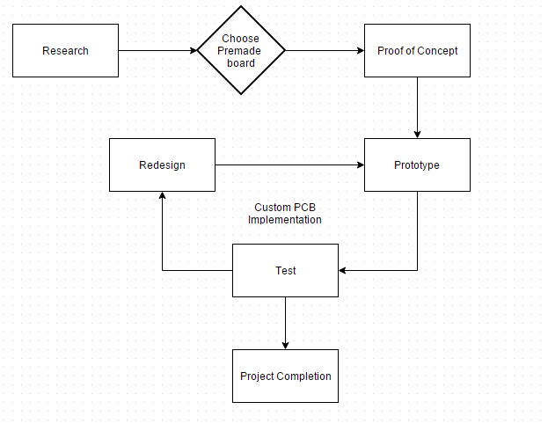

*Figure 7.0-1*

The diagram above shows the planned project progression as it pertains to the microcontroller and peripherals to be used in this project. These stages will be referenced throughout this section.

**7.1 Suitable Microcontrollers for Proof of Concept**

Using a premade, single microcontroller board will allow us to ensure that we can achieve our desired end goal. Due to our constraint of having our data transmitter reach speeds in the megabits per second range, we want to use a board that may have more that we will finally need as it will give us a good baseline of how fast of a microcontroller we will eventually need. With that in mind, we have narrowed the vast amount of microcontrollers, down to three possible options that are within our budget and can be easily replaced if they were to suffer from a catastrophic failure in the prototyping stage.

* Arduino Mega**:** The Arduino Mega is an 8-bit microcontroller board with a various amount of relevant features which could be utilized for this project. First and foremost, it has 54 digital I/O pins, 16 analog inputs and 4 UARTs. The I/O pins are rated up to 20 mA each and it uses an ATmega2560 microcontroller with a clock speed of 16MHz.
* Raspberry Pi 2:The Raspberry Pi 2 is a microcontroller board with a very powerful 900 MHz quad-core CPU. The Model B has 40 general purpose I/O pins, rated up to 3.3 volts. It also supports one UART via the pin connector.
* TI – MSP-EXP430G2:The Launchpad based on the MSP430 is a low cost limited functionality board, which could be used for some early testing. The board has a 16Mhz microcontroller, 16KB of flash memory, a comparator, and 1 UART.

|  |  |  |  |  |
| --- | --- | --- | --- | --- |
| **Table 7.1-1 Comparison of relevant features for proof of concept microcontroller boards** | | | | |
|  | **Clock Speed (AVG)** | **Digital output pins** | **DC current per Pin** | **Cost** |
| **Arduino Mega** | 16 MHz | Yes | 20 mA | $13.49 |
| **Raspberry Pi 2 (Model B)** | 900 MHz | Yes | 16 mA | $34.99 |
| **TI – MSP-EXP430G2** | 16 MHz | Yes | N/A | $9.99 |

**7.1.1 Proof of concept phase board choice**

For our proof of concept stage, we plan to use an Arduino Mega. This board is a good starting point as it will be able to power our laser at low voltages and has a fast enough average clock speed that it will not act as a ceiling to limit the speed of our data transfer. Since we will need two premade boards, one for the transmitter side and the receiver side, it will be simpler and more efficient to have both boards be the same. The hardware on the Arduino Mega also will be the most similar to what we plan to use eventually for our custom microcontroller board.

**7.2 Components of the custom prototype boards**

The two required custom made single-microcontroller boards, one for the transmitter side and one for the receiver side, will be near identical in their design. The only major difference between the two boards will be the inclusion of a driver circuit on the transmitter side, while the receiver side will have a signal processor to analysis what the photodetector is receiving from the transmitter. The components that will be present on both boards are the microcontroller, USB to Serial Converter, and the notification LED. The only difference in parts for the two boards is that the microcontroller board on the transmitter side will include a driver circuit while the receiver side will feature a photodiode with some signal processing components to attempt to clear the signal of some noise.

**7.2.1 Shared components of the custom boards**

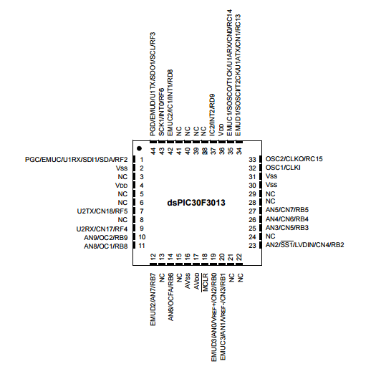**Microcontroller:** Based on our proof of concept board selection, we decided on a microcontroller that is similar enough to the Arduino Mega, in which we could expect to find similar results. The Microchip dsPIC30F3013-20I/SO

*Figure 7.2.1-1*

microcontroller has features similar enough to our proof of concept that we feel we could replicate or obtain similar results with. Its key features are a 16-bit architecture, a CPU speed of 20MIPS, 24KB memory, 2KB of RAM and 2 UARTs. It also features a C compiler, which allow us to port most of our proof of concept code into the new board without having to alter much of the code except for some minor syntactic changes.

Other features of this controller that will assist us in this project are its I/O max currents of 25mA, which will be just enough to run the laser at its minimum potential and its 16-bit & 32-bit timer modules. If needed the board also has an Analog-to-Digital Converter which can be useful if we would want to experiment with sending analog signals over laser instead of digital signals. This microcontroller is also cost effective and is readily available if extras or replacements are needed in the case of damage or catastrophic failure. Below is a breakdown of the features included in the Microchip dsPIC30F3013-20I/SO microcontroller.

|  |  |  |  |
| --- | --- | --- | --- |
| **Table 7.2.1-2: Microchip dsPIC30F3013-20I/SO** | | | |
| **Architecture** | 16-bit | I/O Pins | 20 |
| **CPU Speed** | 20 MIPS | Analog Peripherals | 1 Analog-to-Digital |
| **Flash Memory** | 24 KB | Operating Voltage Range | 2.5V to 5.5V |
| **RAM** | 2 KB | Programming Language | C |
| **Connections** | 2 UART | 1SPI | 1 I2C |  |  |

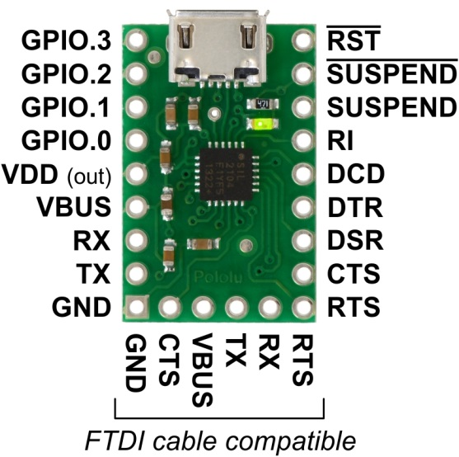**USB to Serial Converter:** The purpose of this component is to allow for passage of data between the PC and microcontroller. Without this piece, there is no viable way to pass data to the microcontroller

*Figure 7.2.1-3*

as it’s only input is a UART.We will be using a premade breakout board for this made by Pololu.

This board is a USB to serial adapter for the Silicon Labs CP2104 USB-to-UART bridge. Using this board will streamline our prototyping stage as we will not need to construct a board for connecting and passing data from our PC to our microcontroller.

The board itself is budget friendly, and will be easy to sit on our custom board. This board will handle communication from the PC to the microcontroller as well as powering the microcontroller itself.

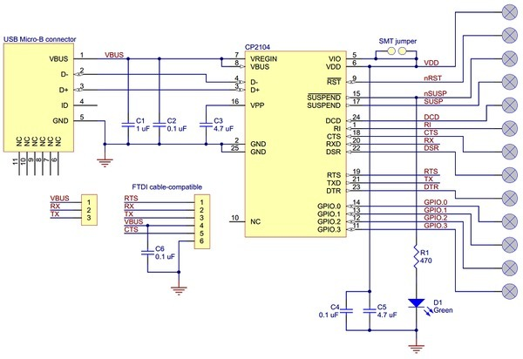The board will be powered via the VBUS pin which supplies five volts from the USB port on the PC. The five volts will be enough to supply power to the microcontroller and LED to allow them to function. The only other pins that will be used on this breakout board are the RX and TX pins which are used for UART transmission and receiving. The pins will be directly connected to the RX and TX pins on the microcontroller which should serve as the link to be able to load programs and gather data from the Microchip microcontroller.

*Figure 7.2.1-4*

**Notification LED:** This component, which will be present on both sides (transmitter and receiver) will act as a safety and debugging tool for us to use. On the transmitter side, the LED will light up when the laser is transmitting, which will alert us that the laser is actually functioning and to inform us that the laser is on, as the laser cannot be seen with the naked eye. This allows us to take an extra safety step to ensure the safety of everyone involved to prevent eye damage. On the receiver side, the LED will act as a notification for us to actually view that the laser is being successfully received by the photodetector.

**7.3 Transmitter side Microcontroller board**

The microcontroller on the transmitter side of the project will have all the parts mentioned in the previous section (7.2.1 Shared components of the custom boards) and the driver circuit, which was discussed and is the planned schematic for the custom single-microcontroller board which we plan to use in the prototyping phase on the transmitter side of the project.

**7.3.1 Code structure**

The microcontroller on the transmitter side of our device will act as our modulator, as we can pulse our signal through a microcontroller with a simple on-off through one of the many output ports found on a microcontroller. This pulsing will result in a time modulation as the receiver will be able to receive a binary on/off signal if it knows how much time to wait in between each binary string. The software will follow an object oriented style approach and have three main stages: input, encode, and transmit

*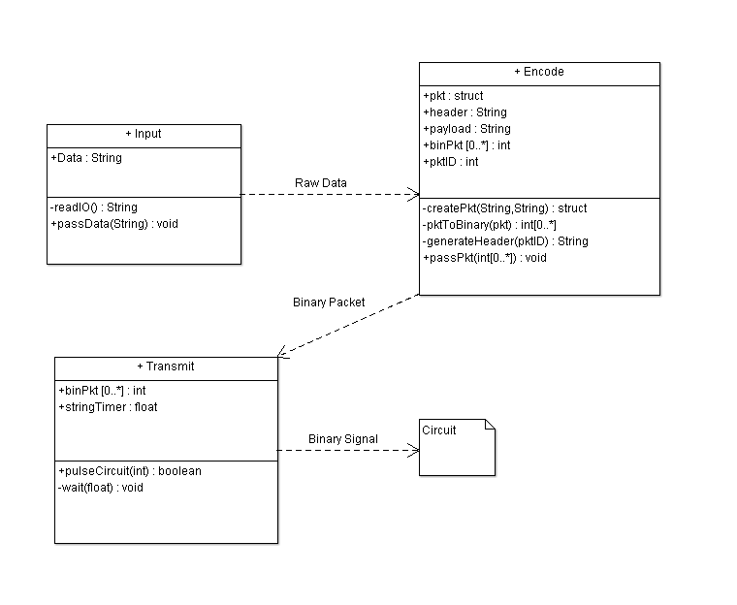Figure 7.3-1*

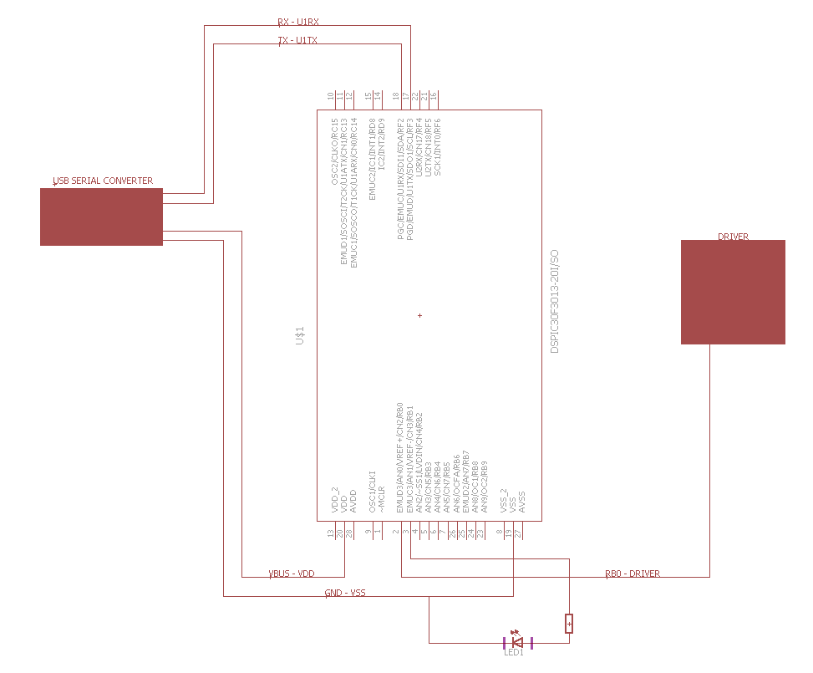

**

Figure 7.3-2

**Input:** This stage will read in user-generated data from a personal computer. While the program is active, it will constantly take in any new data from a user to be read in and pass it to the next staging process.

**Encode**: This stage will receive data from the previous input stage and decide how to handle this data. In most cases, it will attempt to convert the data received to a binary format and create an “IP-style” packet. The packet will consist of a header, which includes general information to be used by the receiver, and the payload, which is the user entered data.

The information that will be contained in the header of the packet are flags or error codes to detect if a packet has failed or has suffered any interference during transmission. Although no problems are to be expected during initial testing of the transmission, as a short range, controlled environment laser should not incur a large amount of loss or corruption.

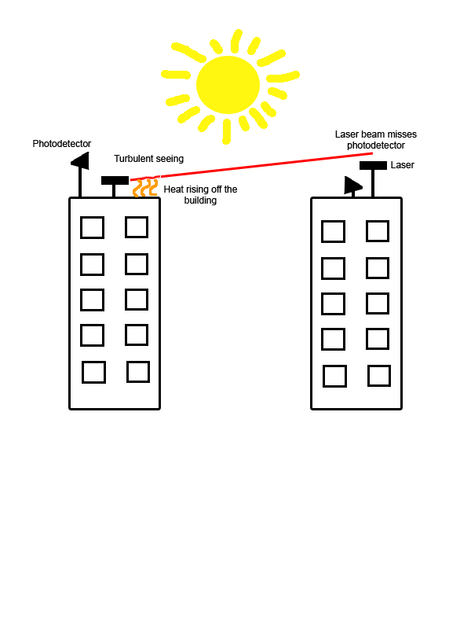

*Figure 7.3-3* *Convection currents causing interference with a bidirectional laser communication system.*

This addition will also allow us to scale up the project and increase the distance to where packet loss will eventually become a common issue that will need to be handled. This packet loss can be caused by various environmental factors and these tests will be done in Florida, where the sun and heat will be one of our biggest environmental factors. If we do not take this into account, we can face the possibility of a large amount of data being lost, as the environment can cause an issue similar to that shown in the figure above.

**Transmit:** This stage will receive the packet, which is just a binary string, from the Encode stage. It will take that received packet and pulse one of the output ports on the microcontroller. This port will be connected to our transmit circuit which consists of the laser, driver circuit, etc. The port will pulse a current either on or off, with which the circuit will decide how to pulse the laser.

**7.3.2 Connection to Driver Circuit**

The driver circuit will be attached directly onto the custom board with a signal pin being attached to it. A possible issue with this setup that will have to be dealt with is the possibility of needing more current than the microcontroller can output, which will put the microcontroller at risk of being destroyed. This may have to be resolved by adding a separate current source to the driver or having multiple pins output current to the driver synonymously, which may not be possible due to timing issues.

**7.4 Receiver Microcontroller**

The microcontroller on the receiver side of the project will have all the parts mentioned in one of the previous sections (7.2.1 Shared components of the custom boards) and the photodiode circuit, which is discussed in detail in section 4.1. Below is the planned schematic for the custom single-microcontroller board which we plan to use in the prototyping phase on the receiver side of the project. The design of this board are nearly identical to that of the transmitter side.

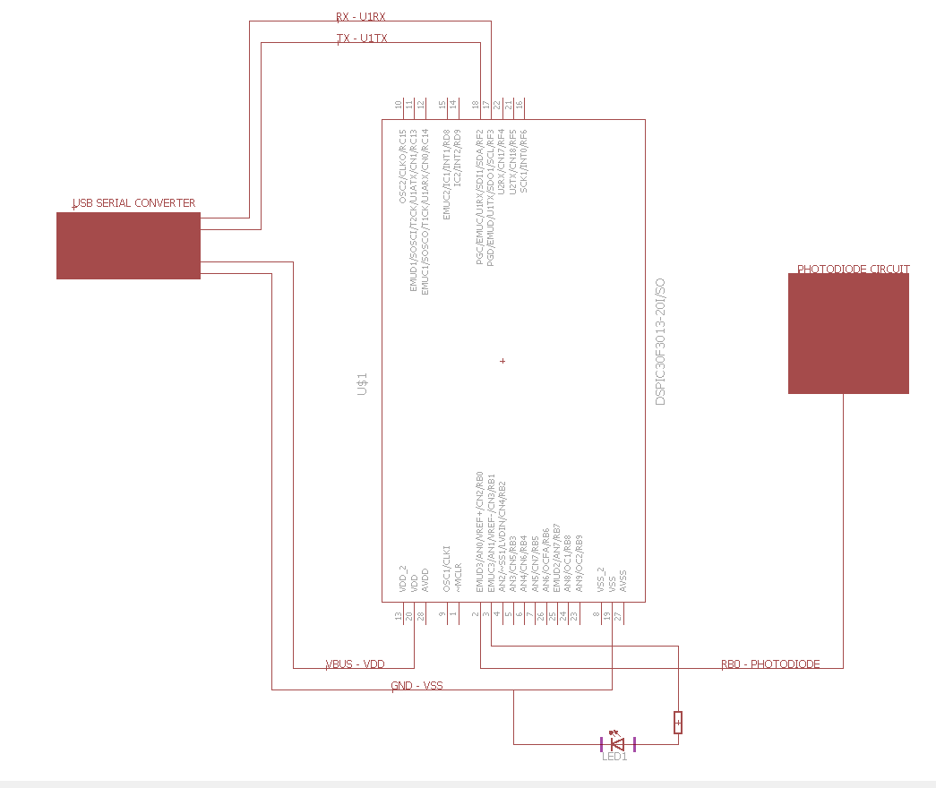

*Figure 7.4-1*

**7.4.1 Code structure**

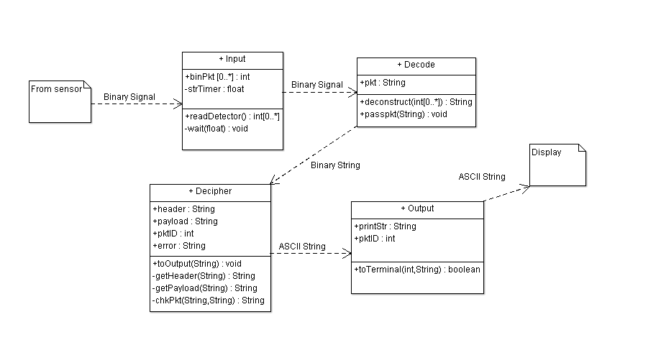The microcontroller on the receiver side of our device will act as our demodulator, as it will be able to differentiate the pulses sent by the transmitter by the software running on the microcontroller. Since the incoming data will be time modulated, we can set a delay of the software to tell packets apart from each other. The code structure of the receiver software will also follow an object oriented approach, in which it will be sectioned out into four main stages: input, decode, decipher, and output.

*Figure 7.4.1-1*

**Input:** This stage will be the most active stage during the receiver’s runtime. It will be constantly running and waiting for the transmitter to send a signal. Once that signal is received, the input stage will read in the full string and pass it to the decode stage.

**Decode:** This stage will receive the signal data or packet from the previous stage and deconstruct it into one continuous string to be deciphered in the next stage. The most difficult challenge in this stage will be to successfully reconstruct the signal, especially in the vent of loss or interference. If the signal cannot be properly decoded, it will not be able to be deciphered and result in an error.

**Decipher:** This stage will take in the decoded binary string and attempt to deconstruct the header and payload portions of the packet. If the stage is successful in deconstructing the header and payload, the payload and packet identifier will be passed on to the next stage to be output. The header is used to ensure the current frame of the receiver matches that of the packet sent by the transmitter. If the frames do not match, the receiver will assume that the previous packet has been lost, and will report an error. This lost packet will also have to be dropped as the channels currently in the project are not planned to be bidirectional.

**Output:** This stage will receive the converted payload and packet identifier, which will have been passed as an ASCII String to be printed out to the user. This will be achieved via a serial connection from a personal computer to the receiver end microcontroller to exchange data.

**7.4.2 Connection to Sensor Circuit**

The microcontroller will be at the end of the Sensor Circuit to read in the data from its digital I/O pins. Since the microcontroller and receiver circuit must be in always on, it will require a steady supply of power that can constantly maintain the system. If the power drops below an acceptable range, there is a high probability of a packet being lost. This will be taken into account when designing the power system for the project.

**7.4.3 Handling lost or corrupted packets**

There are currently no plans to expand this project to have a bidirectional channel, loss and corruption cannot be dealt with by traditional networking means, where the receiver would simply request for the packet to be resent. The only currently available option to us is to simply detect when an error occurs and report it to the terminal. These erroneous packets have to be dealt with each in their own way and will be discussed separately in this section.

**Packet loss:** To deal with packet loss, we will have to delve into the header information which will be included in the packet upon creation. During the packet’s creation, there will be header information added. This information will include a Sequence number, size of the payload, and a timestamp. The sequence number or SEQ will act as a packet’s identifier, and conventionally the SEQ number will increase by the size of the payload. This can be seen in the diagram below.

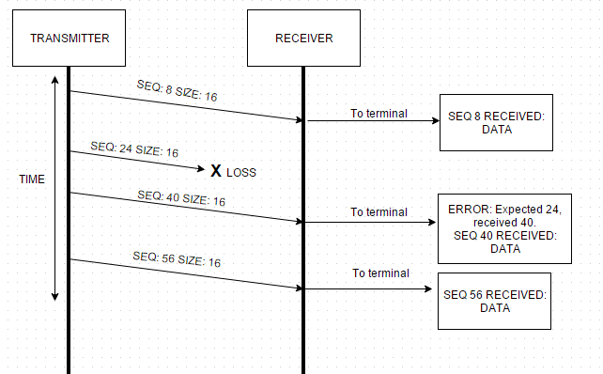

*Figure 7.4.3-1*

As you can see in the above diagram, when the receiver obtains the first packet, it knows the first packet’s SEQ number and the size of that packet. The next packet the receiver will be expecting should have a SEQ of the previous SEQ plus the size of the previous packet, or in this case 24. In this scenario, the packet with SEQ 24 is lost, so when the next packet is sent with the SEQ of 40, the receiver will know that the packet with SEQ 24 never arrived and is assumed lost. It will then report this error to the terminal to let the user know that the packet was lost in transmission.

**Packet corruption:** As with packet loss, there is no efficient way to deal with packet corruption so the most we can do in this situation is report the error when it is obtained. A packet can be corrupted from a numerous amount of reasons, from signal interference, power fluctuations, environmental factors, and etc., so aside from removing as many sources of interference as possible it is difficult to account for all errors. A scenario of a packet corruption can be seen in the diagram below.

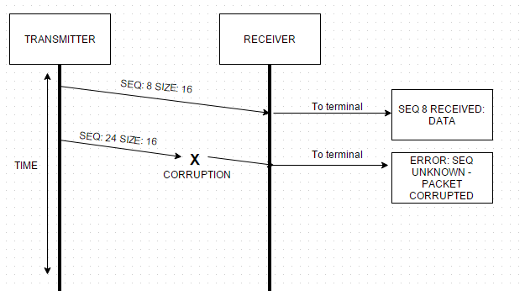

*Figure 7.4.3-2*

Packet corruption can potentially be very difficult to account for as there is a slim possibility that the header remains unaffected, but the payload is corrupted. This may be alleviated by the implementing a checksum of some sort where the checksum is calculated and cross checked with a checksum of the packet on the receiver end of the network. Hopefully, packet corruption should be a fairly rare issue to occur as using a laser over short distances in a controlled environment should reduce any outside influences on the laser and signal itself.

**8.0 Circuits**

An electronic circuit is a network of electronic components connected by wires that have an electric current flowing. There is an infinite amount of combinations for these electronic components that have an array of operations. Circuits can be made different ways, but modern techniques are used to write on printed circuit boards (PCB) and solder flip chips onto these PCBs. Integrated circuits are another way to create a circuit board, this method uses microelectronic techniques on a substrate that contains various semiconductors. However, breadboards are commonly used for testing new designs. Additionally there are three types of electronic circuits; an analog circuit, a digital circuit, and a mixed-signal circuit.

**8.1 Analog Circuit**

Analog circuits have continuous and variable signals, and can carry information by current, voltage, or frequency. These circuits use a combination of fundamental electronic components, that are analog, and each component has a specific symbol used as a visual representation. Figure 8.1-1 shows some common analog circuit symbols. Additionally, Figure 8.1-2 shows most of the common power supply symbols. Although these circuits are difficult to design the benefit of using an analog circuit is that no information will be lost since the output is also analog. Additionally, amplifiers and filters are the considered the most important application of an analog circuit.

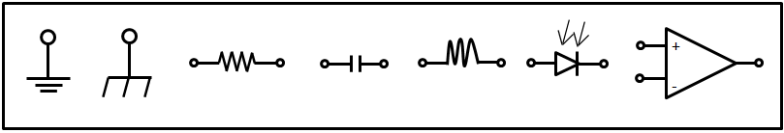

*Figure 8.1-1: Starting from the left, the first symbol is called the earth ground and is used as a zero potential reference and for electrical shock protection. Following is the chassis ground, also a zero potential reference but is connected to the chassis of the circuit board. The third symbol is a resistor and is used to reduce current flow. The fourth symbol is a capacitor and is used to store electric charge and acts as a short circuit with AC and an open circuit with DC. The fifth symbol is an inductor that represents a coil and generates a magnetic field. The sixth is a photodiode and allows current to flow when it is exposed to light. Finally, the last component is an operational amplifier and amplifies the input signal*.

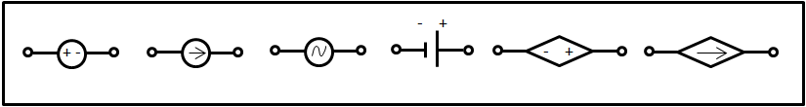

*Figure 8.1-2: Starting from the left, the first power supply symbol is a voltage source that generates a constant voltage. The next symbol is a current source and generates a constant current, following with an AC voltage source. The fourth symbol is a battery and also generates a constant voltage. The fifth symbol is a controlled voltage source and generates a voltage as a function voltage or current of other circuit elements. The last symbol is a controlled current source and generates current as a function of voltage or current of other circuit elements.*

**8.1.1 Analog Circuit Schematics**

A circuit schematic is a graphical representation, similar to a blue print of a building, of an electrical circuit. The use of a circuit schematic is necessary for analyzing and building the circuit. Each circuit schematic uses electrical symbols that represent the electrical components on a circuit and an example of an analog circuit schematic is shown below as figure 8.1.1-1.

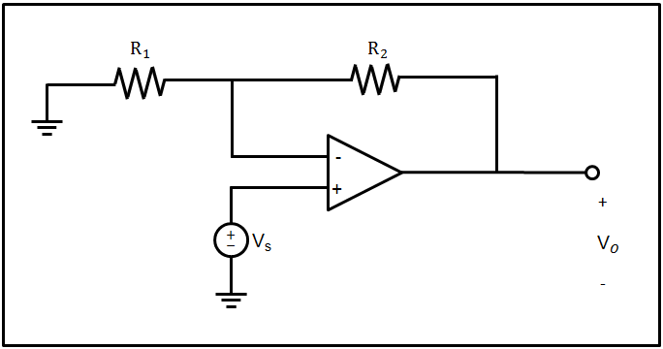

Figure 8.1.1-1: Basic non-inverting amplifier.

**8.2 Laser Driver**

Upon choosing the appropriate laser for the project, the next component in the process is a way to modulate the laser. The easiest method discussed in the laser modulation section was pulse code modulation, also broadly known as direct modulation. Modulating the current being sent to the Mitsubishi FU-68SDF-V802MxxB laser is the most effective solution to driving the laser. This is because the Mitsubishi FU-68SDF-V802MxxB laser package was designed for be current driven. Figure 8.2-1 is a Light vs Current diagram, or LI Diagram, that characterizes the laser operation. The laser receives an input current (green) and transmits a signal (red) of greater amplitude to the receiver. The frequency of both the input and output currents remain the same throughout this process, which means the group is restricted to only manipulating the lasers input current source to achieve high speed data rates. One of the most common and effective methods to manipulating the input current source to the laser is with a current driver. In order to meet product specifications the group researched different laser diode drivers currently on the market and determined the most compatible driver to achieve the highest possible data rates. The following section is a comparison of the top three laser drivers on the market.

**Threshold Current**

*Figure 8.2-1*

**8.2.1 Product Comparison**

To get an idea of the capabilities of laser diode drivers the group researched three different drivers. Table 8.2.1-1 is a comparison between these three drivers.

|  |  |  |  |  |  |  |
| --- | --- | --- | --- | --- | --- | --- |
| **Table 8.2.1-1 Laser Diode Diver Comparison** | | | | | | |
|  | **Supply Voltage (V)** | **Min Bias Current**  **(mA)** | **Packaging Configuration** | **Data Rates**  **(Gbps)** | **Pulse Width**  **(ps)** | **Price**  **$** |
| **Texas Instruments**  **ONET1101L** | 3.3 | 5 | QFN Package | 2-11.3 | 60 | Sample |
| **Mindspeed** **M02067** | 3.3 | 4 | Tray | up to 2.1 | <150 | 8.50 |
| **Philips**  **TZA3047A** | 3.3 | 5 | BCG | .030-1.25 | 300 | 10 |

The chosen laser diode drivers are all RoHS compliant. Driver components are constructed out of hazardous materials. In order to limit the amount of hazardous materials the driver is assembled out of restrictions are placed on these components and others. Table 8.2.1-2 is a list of hazardous materials and there limitations.

|  |  |
| --- | --- |
| **Table 8.2.1-2 Hazardous Material Restrictions to Meet RoHS Standards** | |
| **Lead (Pb)** | < 1000 ppm |
| **Mercury (Hg)** | < 100 ppm |
| **Cadmium (Cd)** | < 100 ppm |
| **Hexavalent Chromium: (Cr VI)** | < 1000 ppm |
| **Polybrominated Biphenyls (PBB)** | < 1000 ppm |
| **Polybrominated Diphenyl Ethers (PBDE)** | < 1000 ppm |
| **Bis(2-Ethylhexyl) phthalate (DEHP)** | < 1000 ppm |
| **Benzyl butyl phthalate (BBP)** | < 1000 ppm |
| **Dibutyl phthalate (DBP)** | < 1000 ppm |
| **Diisobutyl phthalate (DIBP)** | < 1000 ppm |

It’s not only important to maintain RoHS compliance for environmental reasons, but also because the RoHS compliant components are easily accessible to the consumer in the United States. Upon reviewing the laser diode drivers above the Texas Instruments model ONET1101L driver would suit the project best. The driver is capable of pulse widths at 60ps (30ps rise time and 30ps fall time), which is around 67 times faster than the Mitsubishi FU-68SDF-V802MxxB laser can be pulsed to. The limiting factor is then the laser. The chosen laser diode driver also meets ESD (Electrostatic discharge) standards. Electrostatic discharge control is an important standard to upkeep. According to the ANSI/ESD S5.3.1-2009 standard this device maintains ground contact, uses static dissipative materials to replace insulators and uses air ionization to neutralize charge on device packages. Some of these methods of control aid to prevent the component from receiving or sending out electrostatic discharge. MSL (Moisture sensitivity level) standards are also met. There are 7 levels to MSL that corresponds to the amount of time a component can be set on a shelve before being heated up, or baked: MSL 1-Unlimited time, MSL 2-1 year, MSL2A-2 weeks, MSL 3-168 hours, MSL 4-72 hours, MSL 5-48 hours, MSL 5A-24 hours, and MSL 6-Mandatory bake before use. The laser diode driver chosen is a MSL 2 level and, therefore, meets the standard according to IPC-M-109. The laser driver is also capable of between 2-11.3 Gbps. This bit-rate range meets the specifications of the project, highlighted in the design specification section of this document. The following section describes some capabilities that will be useful when designing the project.

**8.2.2 Texas Instruments ONET1101L Attributes**

The ONET1101L laser driver is an integrated circuit with multiple specifications this project can utilize. Table 8.8.2-1 is a comparison between the decided laser for the project and the laser driver circuit to verify that the two components will be compatible with each other. From this table it is apparent that both components can operate simultaneously to provide the project with a modulated laser signal.

|  |  |  |  |
| --- | --- | --- | --- |
| **Table 8.2.2-1 Component matching: Laser with Laser Driver** | | | |
|  | **Mitsubishi FU-68SDF-V802MxxB** | **Texas Instruments**  **ONET1101L** | **Matched** |
| **Supply/Operating Voltage** | 1.3-1.8V | 3.3V |  |
| **Supply/Operating Current** | 40-65mA | 66-85mA |  |
| **Pulse Width** | 150ps | 70ps |  |
| **Voltage Regulating Photodiode Supply/Forward Current** | 2mA | 3.080mA |  |
| **Input/Output Impedance** | 25Ω | 25Ω |  |

The Texas Instruments ONET1101L is also configured in a QFN packaging scheme, making integration onto the PCB microcontroller seamless. The next section describes the QFN package and why it is beneficial to PCB designs.

**8.2.3 QFN Packaging**

QFN stands for Quad Flat No-Lead, and has quickly became an industry standard when designing PCBs. Figure 8.2.3-1 was taken using a program called Eagle and is a picture of the pin layout of the laser driver being incorporated into the laser data transmission project.

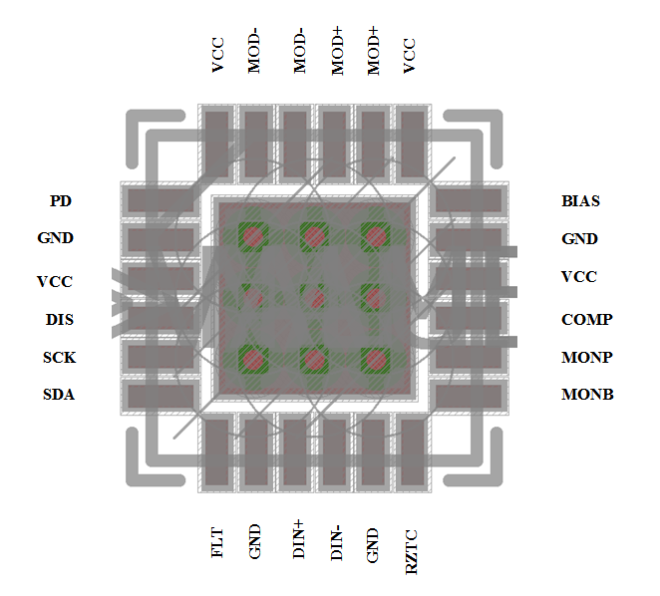

*Figure 8.2.3-1*

This packaging type is advantageous to the consumer because the contacts are directly under the package chip so the leads are not exposed. The QFN package also sits flush with the PCB board. This will mitigate any damage that can be done to the chip by means of transporting or moving the PCB. The package is very small. Texas Instruments ONET1101L laser driver dimensions are 4mm x 4mm x 1mm. This small profile demands less overall PCB area allowing for either a smaller PCB board or other component space. The next section will introduce the laser driver design.

**8.3 AC to DC Converter Characteristics**

A AC to DC converter is a key essential to transmitting a viable modulated signal to the photodetector. The AC to DC converter converts a digital input signal from an input device, such as a computer, to an analog signal that will modulate current driving the laser beam. The three main jobs a digital to analog convert is responsible for performing is

1. Sampling Amplitude- the digital to analog converter creates a continuous, or analog, current signal equal to a numeric value read from a computer file. The more accurately the converter can perform this task the higher quantization level the laser system can transmit.
2. Sample Timing- the digital to analog converter must also establish the analog current signal with a stable timing that can be detectable by the laser. If an analog current signal had timing faster than the laser could modulate then data would be lost.
3. Filling in errors- there is a certain error that occurs throughout the digital to analog converting process. This “quantization error” can be mitigated through the use of a clock signal that synchronizes the entire system to check the laser signal at discrete times.

There are several methods to designing a AC to DC converter. Some of the more popular methods are as follows:

1. Pulse width modulation is a form of modulation where data is represented by the ratio of the time to the total time, or duty cycle. Pulse width modulation is one of the easiest methods to control a digitally encoded analog signal.
2. Oversampling or interpolating- interpolating is a digital circuit that accepts a low rate data signal, adds zeros at a high rate, and then applies a digital filter algorithm and outputs an analog signal at a high rate. A primary circuit lta-sigma digital to analog converter.
3. Binary-weighted-contains electrical components for each bit and a summing point. Binary weighted digital to analog converters produce very fast analog signals, but are not precise. The cost to produce an efficient binary-weighted digital to analog is too high. This component will not be practical when maintaining a budget.
4. R-2R ladder- is similar to the binary weighted digital to analog converter except it uses cascaded repeating resistor values. This method increases precision, but decreases the speed in which the analog signal can modulate the laser.
5. Cyclic or successive approximation- this digital to analog converter allows each digital input to be processed in each cycle.
6. Thermometer-coded- contains an equal resistor or current source segments. This is one of the most efficient digital to analog converters but the converter is expensive and cannot be incorporated in this project.

Upon researching of the process of AC to DC converters it will not be beneficial to this project for signal transfer. Analog signals typically can be modulated at higher rates. As the modulation rate of an analog signal increases the signal noise increases. TO compensate for the increased noise complex filter circuits would have to be incorporated that can eliminate frequencies that cause noise. These filters sacrifice amplitude to perform this task. Losing any amplitude is not ideal for the purposes of this project. Instead if the laser was pumped with a square digital current source it can transmit much higher amplitudes. Rise and fall times of the laser and receiver become the limiting factor. The components we have chosen for this project have rise and fall times in the picosecond range which will yield Gbps data transmissions. The next section will discuss the design of the laser diode driver component. The following section will utilize the AC to DC characteristics to design an AC to DC power converter.

**8.2.4 Design of AC to DC Converter for Transmitter**

Once power is received be the microcontroller from the wall, the power must then be further controlled and regulated to various components. The first major component, located on the transmitter microcontroller, is the laser diode driver. This component requires a supply voltage of 3.3V to the VCC pins and a supply current of 0.050A split across 2 input pins. In order to accommodate these requirements the designers of the LDT project chose to incorporate DC to DC regulator circuit that will take the input voltage from the microcontroller, at 9V and regulate that voltage to a 3.3V source. There are a few advantages to using a DC to DC regulator. First the DC to DC regulator will protect the laser diode driver, and other components from receiving too much voltage or current. Also, when driving a laser diode, it is important to maintain a steady supply voltage. Any fluctuations in the supply voltage will alter the amplitude of the transmitting signal vastly. To design a DC to DC regulator I used Webench. This is a tool created by Texas Instruments to build and optimize small circuits. I then reconstructed the designs by Webench in Eagle to create a board design as well as a schematic representation. Figure 8.2.4-1 is the first designed DC to DC regulator for the laser diode driver:

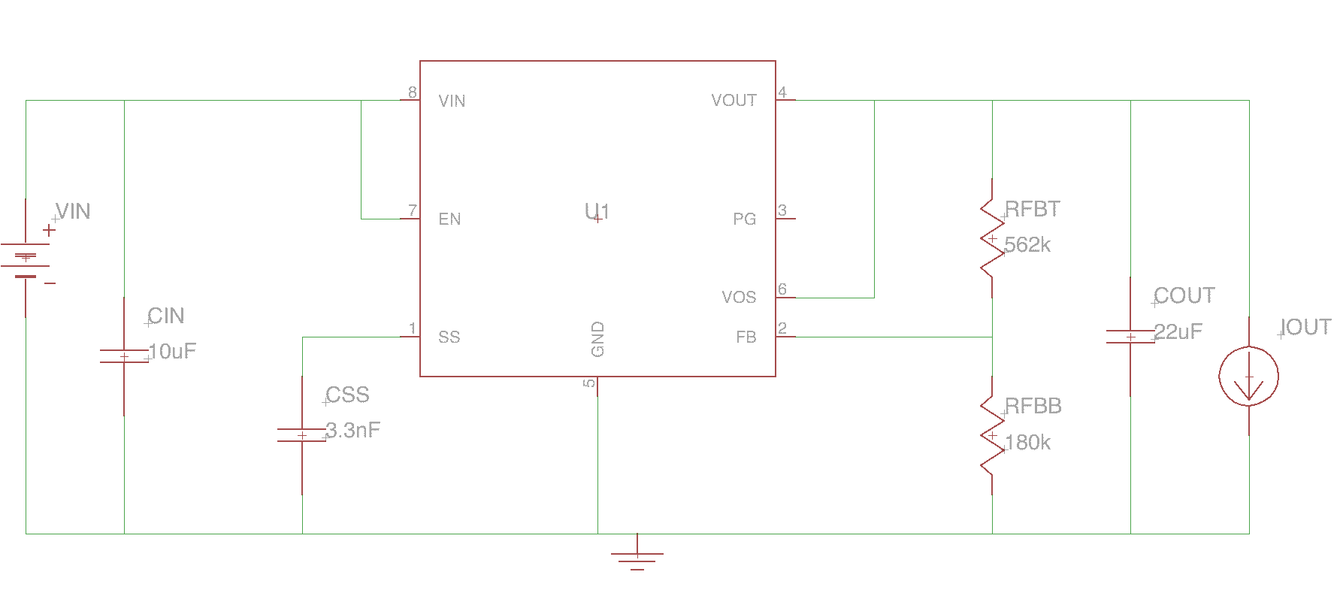

*Figure 8.2.4-1 First designed DC to DC Regulator*

This design is the cheapest of the three designs the group created. It has a small surface area as well with a 72% power efficiency. The most desirable trait of this circuit is that it can operate off a high frequencies which will allow us to design a PCB that operates off a high frequency as well. This will aid in driving the laser diode. Figure 8.2.4-2 is the second designed DC to DC regulator circuit.

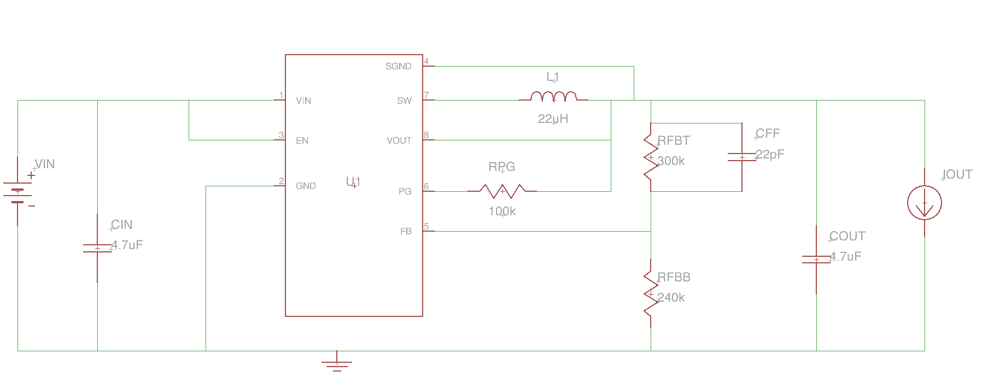

*Figure 8.2.4-2 Second designed DC to DC Regulator*

This second design is similar to the first in almost every way except it is slightly more expensive. For this reason the second circuit will not be used in the design. Figure 8.2.4-3 is the third and last designed DC to DC regulator circuit.

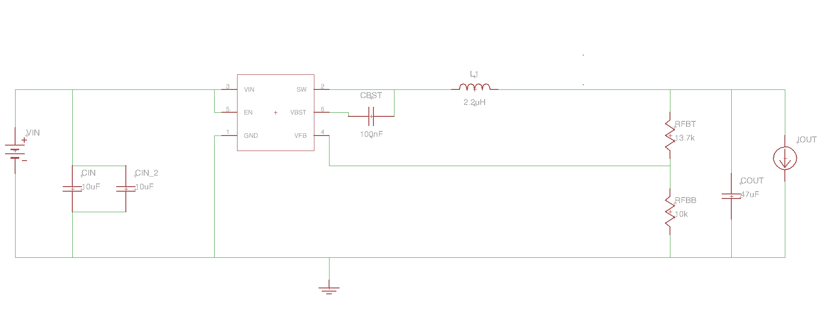

*Figure 8.2.4-3 Third designed DC to DC Regulator*

The last design is a simple in construction, which makes it more desirable. It is the most expensive, though the cost difference between the three circuits are negligible. The most undesirable trait of this circuit is the operating frequency is low. This is a good circuit to prototype with because the Audunio Due operates on lower pin frequencies of 64kHz, but for PCB design the group will hav eto use a higher operating frequency. Table 8.2.4-4 is a product comparsion of the three designed circuits and their attributes.

|  |  |  |  |  |  |
| --- | --- | --- | --- | --- | --- |
| **Table 8.2.4-4 Product Comparison DC to DC regulator Circuit Design** | | | | | |
|  | **Components** | **Bill of Materials Cost** | **Efficiency** | **Frequency** | **Temperature** |
| TPS62122 | 7 | $0.68 | 72% | 874kHz | 35°C |
| TPS62120 | 8 | $0.69 | 72% | 874kHz | 35°C |
| TPS563200 | 7 | $0.89 | 84% | 78kHz | 31°C |

Upon analysis of the three different circuit designs it would be most beneficial to use the first circuit, or TSP62122 as seen in Figure 8.2.1-1. This circuit contains the most desirable characteristics such as high operating frequency, meets the standard 9V at 1A input to 3.3V output at 50mA regulation, and is cheap. Efficiency is not a big concern we will be using the wall as our power source and not a battery.

**8.2.5 Design Laser Diode Driver**

The laser diode driver is a key component in transmitting a useable data signal so the design of the driver is extremely important. Figure 8.2.5-1 is a schematic representation of initial design of the laser diode driver. The schematic, designed using a program called EagleCAD allows the design team to get a better understanding of the driver and begin simulating possible circuit behaviors.

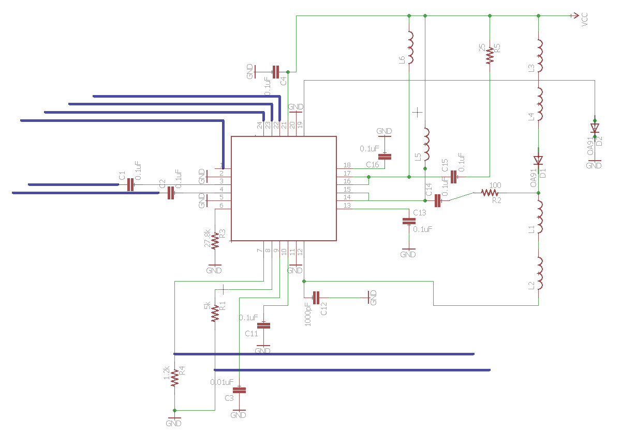

*Figure 8.2.5-1*

Table 8.2.5-2 identifies and offers a brief description of the pins on the driver. The driver will be powered by connecting the VCC pins together in parallel, as each pin will be supplied with 3.3V of power. The transmitting laser, marked D1 in the schematic, will be on pin 13. The driver will function by first accepting a digital square waveform from a computer through the SCK clock and SDA data ports gets modulated and is output through the MOD+ and MOD- pins. MOD+ will bias the transmitting laser diode at high values for the input data signal and MOD- will bias the laser diode at low values. An internal photodiode included in the laser packaging will be connected to pin PD. The scans the laser diode to regulate the output power of the laser. This is necessary to ensure a stable transmission signal. This laser diode driver design will be integrated into the PCB microcontroller design. Please see the microcontroller design section for details.

|  |  |  |
| --- | --- | --- |
| **Table 8.2.5-2 Laser Diode Driver Pin Identification** | | |
| **Port Number** | **Port Identity** | **Description** |
| 1 | FLT | Fault Detection Flag |
| 2 | GND | Ground |
| 3 | DIN+ | Not in use |
| 4 | DIN- | Not in use |
| 5 | GND | Ground |
| 6 | RZTC | Not in use |
| 7 | MONB | Not in use |
| 8 | MONP | Not in use |
| 9 | COMP | Not in use |
| 10 | VCC | 3.3V Power Supply |
| 11 | GND | Ground |
| 12 | BIAS | Not in use |
| 13 | VCC | 3.3V Power Supply |
| 14 | MOD+ | Output Current (high) |
| 15 | MOD+ | Output Current (high) |
| 16 | MOD- | Output Current (low) |
| 17 | MOD- | Output Current (low) |
| 18 | VCC | 3.3V Power Supply |
| 19 | PD | Internal Photodiode |
| 20 | GND | Ground |
| 21 | VCC | 3.3V power supply |
| 22 | DIS | Disables bias and modulation current at high state |
| 23 | SCK | Serial Clock |
| 24 | SDA | Serial Data Input |

**8.3 Photodetector Circuit**

As discussed in chapter 4, a photodetector is a semiconductor device that electrically detects optical signals and converts the optical signal into an electrical signal. The photodetector semiconductor device applies the photovoltaic effect which converts the incident light into an electrical voltage or current. Incident light on a photodetector from a laser diode can either be visible or invisible, infrared, to the naked eye and this property will help choose the correct photodiode for a given circuit. Chapter 4 also discussed the basic processes of various photodetectors that can be used; in the chapter those semiconductor photodetectors will be applied into circuits with additional electrical components to analyze and transfer data.

**8.3.1 Photodiode Circuit Design**

The voltage in a photodiode circuit is in reverse-bias and when no light is incident on the photodiode only a reverse-saturation current is present. A photocurrent is the result of incident light on the diode and is in the reverse-bias direction. The photocurrent can be calculated by , where η is the quantum efficiency, is the electronic charge, Φ is the photon flux (#/) and A is the area of the junction. There is a linear relationship between photon flux and photocurrent, a basic photodiode circuit design is represented in figure 8.3.1-1. Two ways commonly used to operate a photodiode are the photovoltaic mode and photoconductive mode; although both the designs are similar their properties are not.

**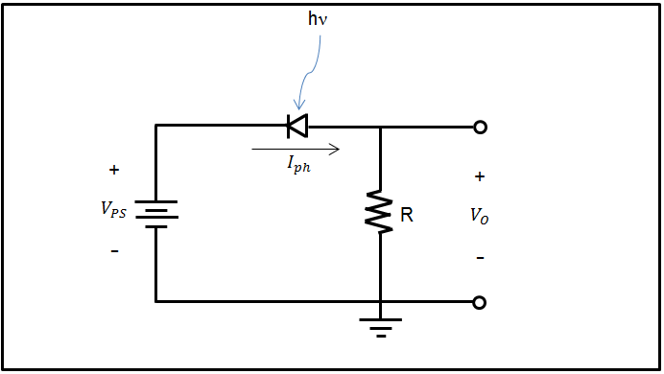***Figure 8.3.1-1: A basic photodiode circuit, the diode is reverse biased. This circuit transforms the photocurrent produced by the photodiode into an output voltage. Where is the output voltage, is the diode voltage, and is the power source voltage.*

**8.3.2. Photoconductive Mode**

As discussed in chapter 4, the photoconductive mode, a type of photoelectric effect, converts light into an electrical current resulting in an increase in the electrical conductivity of a device when exposed to light. For applications that use the photoconductive mode, a reverse bias must be applied resulting in greater response speed, linearity of the device, and lower capacitance. Additionally, the photoconductive mode is used when speed is the key parameter being analyzed.

When a reverse-bias is applied to the photodiode a current leakage becomes present and is known as dark current. Additionally, when incident light is blocked, the resulting output voltage becomes. Key properties of using this circuit under reverse-bias are: High-speed response, and wide output. However, with the simple circuit in figure 8.3.2-1 high sensitivity and speed cannot be achieved at the same time.

As the voltage produced by the photodiode increases the output current no longer remains proportional to the light intensity. By applying an op-amp to the circuit in figure 8.3.1-1, a constant reverse-bias voltage will be obtained for all incident light intensities and a schematic is shown in figure 8.3.1.2.1-1. Additionally, the op-amp will convert the photocurrent into an amplified voltage but due to the resulting capacitance in the photodiode, oscillations can occur in the op-amp. To compensate for the oscillations, a feedback capacitor is connected in series with the resistor as shown in figure 8.3.2-2.

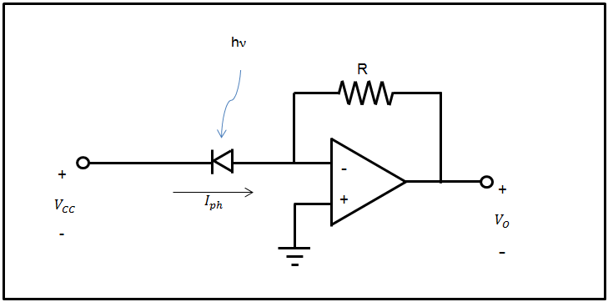

*Figure 8.3.2-1: Schematic of a simple photodiode utilizing the photoconductive mode, this circuit is also known as a transimpedance amplifier.*

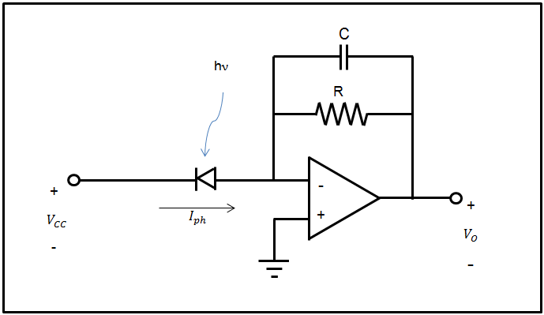

*Figure 8.3.2-2: Schematic of a transimpedance amplifier with a feedback capacitor.*

InGaAs photodiodes, which operate in the near infrared range, are commonly used because to their wide range of applications and will be discussed as a potential photodiode for this design. Understanding the electrical characteristics is important to designing any circuit. The photovoltaic mode is used for precision measurements.

Shunt Resistance, , is used to calculate the noise in the current in photovoltaic mode and is determined by the slope of the current-voltage curve of the photodiode. Low shunt resistance will result in power loss as the photocurrent will have an alternate current path to flow. Additionally, an ideal photodiode has infinite resistance; therefore the greatest achievable shunt resistance is preferred.

Series resistance, is used to determine the linearity of the photodiode under photovoltaic mode. Typically this resistance is irrelevant due to its low value; however a value is observe and is commonly caused by current movement and metal contact in the semiconductor. This can be calculated by , where is the substrate thickness, is the depletion region width, A is the junction area, and ρ is the substrate resistivity, and is the contact resistance.

Junction Capacitance, , is used to determine the speed of the response of the photodiode. The junction capacitance is the same expression for a parallel plate capacitor; however the depletion layer width is considered the spacing between the two plates and is dependent upon the reverse bias voltage and is shown in figure 8.3.2-3. The following equation is used to calculate the junction capacitance of a photodiode: , where is the depletion depth, , is the dielectric constant of the semiconductor material, is the permittivity of free space, is the mobility of electrons at room temperature, is the resistivity of semiconductor material, is the applied voltage and is the built-in voltage. Figure 8.3.2-4 is a schematic of this circuit with the components discussed.

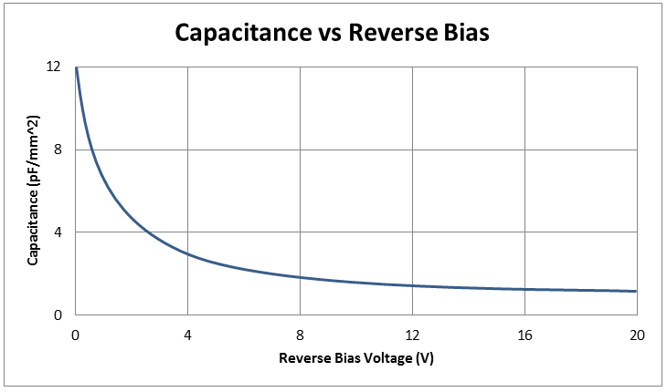

*Figure 8.3.2-3: The figure shows the dependence of capacitance on the reverse bias voltage of a photodiode under the photoconductive mode.*

Rise time (), and fall time (, are times for a signal to rise from 10% to 90% and fall from 90% to 10% of the final value. Commonly expressed as frequency response () and is approximately and is inversely proportional to bandwidth (.

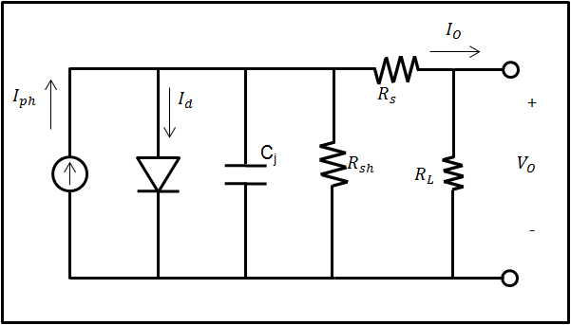

*Figure 8.3.2-4: An ideal photodiode circuit in parallel with a current source. The junction diode is parallel to the shunt resistance that is connected in series with the series resistance. is the load resistance.*

**8.3.2.1 Photovoltaic Mode**

The photovoltaic mode, a type of photoelectric effect, converts light into an electrical current or voltage by using a type of solar cell. When applied to a circuit, as shown in figure 8.3.2.1-1, the photovoltaic mode operates under zero bias voltage resulting in no current and a voltage build up. This mode is typically used for low frequency and low light applications. With no voltage across the photodiode there will be no dark current, to be discussed in the photoconductive mode section, resulting in lower noise and a linear output.

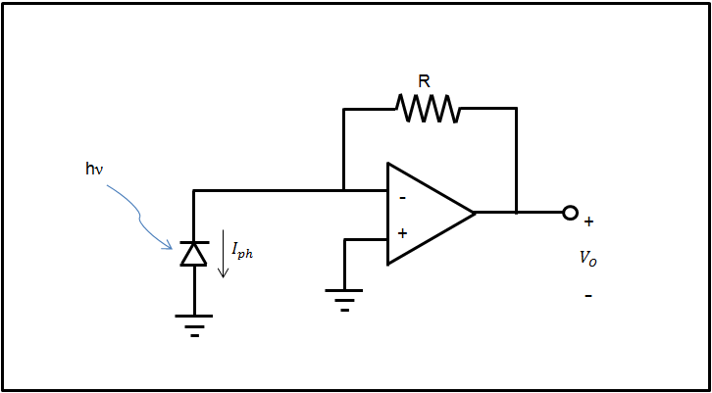

*Figure 8.3.2.1-1: Schematic of a simple photodiode utilizing the photovoltaic mode.*

**8.3.3 Thorlabs InGaAs photodiode circuit**

After selecting the correct photodiode the first circuit to be tested will be the recommended circuit provided by Thorlabs and a schematic of this circuit is shown in figure 8.3.3-1.

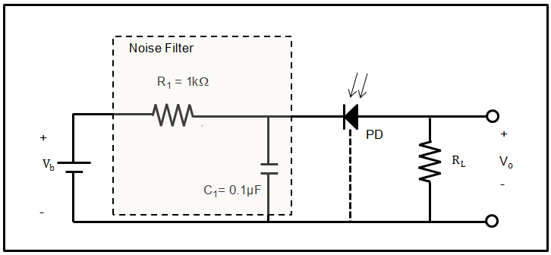

Figure 8.3.3-1: Thorlabs recommended circuit for the FGA01 InGaAS photodiode.

**9.0 Prototype Testing**

Once the project is designed it needs to be tested before major component such as the PCB can be fabricated. Fabrication and testing are dependent on each other and will occur simultaneously therefore our project will be striving to reach our milestones on time. This section focuses on both hardware and software testing. Testing these will ensure a project that meets all specifications requirements, determines functionality, and maintains quality the entire project. This section will test each subsection of the project to confirm that each piece of the design is functioning as intended.

**9.1 Testing Environment**

For the purposes of this project there will be three different types of testing environments. The three types of testing environments are in a laboratory setting, inside common areas and outdoors. Most of the laboratory prototype testing will be conducted in the College of Optic and Photonics undergraduate lab. To test circuitry and other electronic components we may utilize the senior design lab in the College of Electrical Engineering and Computer Science Engineering 2 building. The group will prototype major components together but it will be the responsibility of the individual group member to ensure their smaller subsystems are properly tested. Outside testing will be conducted upon completion of the transmitter to collect data on how the signal will transmit in outside conditions.

**9.2 Transmitter Testing**

How the signal will transmit through the air is a vital component to maximize efficiency. In order to begin testing on the transmitter the group will first construct the housing using Figures 5.6-1, 5.6-2 and 5.6-3 as guidelines. The two major functions required of the transmitter housing for initial prototype testing is having the adjustable feet and a secure location for the laser to be mounted. The laser can then be adjusted according to the needs of the test. The required components for testing will be the laser, the prototype microcontroller, a measuring device, an oscilloscope with input and output connectors and a power meter that reads up to 6mW of power at 1550nm. The power meter and oscilloscope will be supplied courtesy of the College of Optics and Photonics. Simple tests will be conducted to ensure the laser functions properly, and to pulse the laser beam all at varying distances. We will record the results and repeat this process in all three environments. This data will establish a baseline and give the group an idea of the capabilities of the laser system. The group can then design a PCB microcontroller based off the results of the results from testing. The next stage to testing is when the receiver is designed and tested for functionality. The same testing will be conducted in order to draw comparisons between each batch of data results. Once the PCB microcontroller and voltage regulator have been tested for functionality they will be incorporated into the transmitter housing. A third prototype testing date will be required in which the group attempts to recreate the results from the first two tests by using the same clock speed, supply voltage and vary the current in the same matter. The final prototype testing will occur to maximize the bit rate of the system. and voltage regulator have been tested for functionality they will be incorporated into the transmitter housing. A third prototype testing date will be required in which the group attempts to recreate the results from the first two tests by using the same clock speed, supply voltage and vary the current in the same matter. The final prototype testing will occur to maximize the bit rate of the system.

**9.3 Transmitter Subsystem Testing**

There are two subsystem components to the transmitter, which are the voltage regulator circuit and the PCB microcontroller. The designed voltage regulator will be tested by simply observing the input and output waveforms at varying input DC voltages. The regulator will regulate voltage to the laser so the group will be looking for a maximum output voltage of 1.8V to meet the operating voltage of the laser described on the datasheet. Once tested the regulator circuit will be integrated to the transmitter design.

**9.4 Photodiode Testing**

For the testing we will first start of by using the Thorlabs recommended circuit and from there move on to other circuits. The reason for using the recommended circuit is to verify that the photodiode is working correctly and to avoid any damage to the photodiode and surrounding circuitry. Three measurements that will be conducted to verify this will be the responsivity, dark current, and capacitance curves. The results that will be recorded will not be exactly the same as the results obtained by Thorlabs. Figure 9.4-1 is the responsivity observed by Thorlabs, figure 9.4-2 is the Dark Current, and figure 9.4-3 is the capacitance curve.

Figure 9.4-1: Responsivity observed by Thorlabs from 800nm-1700nm.

Figure 9.4-2: Dark current observed by Thorlabs.

Figure 9.4-3: Capacitance observed by Thorlabs.

After we run the experiment a comparison will take place between Thorlabs data and our data. If we see similarities we will proceed to carry out more experiments to ensure that data transfer will occur.

**9.5 Microcontroller and Peripheral testing**

Each testing cycle for ensuring the microcontroller is functioning properly will include three stages of testing. The first stage will test to ensure that the data being transferred from the PC to the microcontroller is being encoded properly to be sent. The second stage is to ensure that the coming incoming data is being decoded properly with as little errors as possible. The third stage is a stress test to see how fast the entire circuit and project will be able to transmit and receive a large amount of data. This test will also measure bit-rate test of how fast we are actually able to transmit. This stage breakdown can be seen in the following diagram.

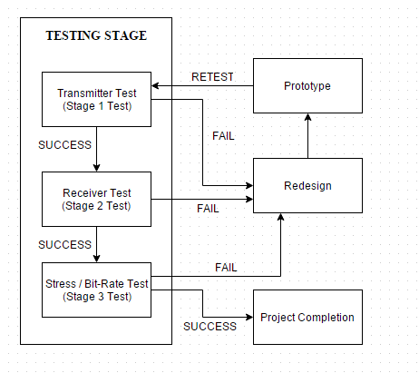

*Figure 9.5-1*

**First Stage:** The first stage of testing will use the following guidelines and will be considered failing if any of these steps execute erroneously or fail to execute.

1. Port transmitter programs to their respective boards.
2. Ensure after the program is running that the microcontroller can receive commands via a terminal from the PC and execute said commands.
3. Use a debugging mode of the program to ensure that the entered data is converted properly through the staging pipeline for the transmitter (Input -> Encode -> Transmit)
4. Ensure that LED is in an on state after the final stage of the program being run.

Following these guidelines during the custom PCB implementation and the proof of concept section should allow us to debug and see if there is an error where it is occurring and what the root cause of it could be on the transmitter’s end of the project. If an error occurs in step one, the error is most likely in the connection between the PC and microcontroller. If an error occurs in step two, there is a probable issue with the UART connection. If an error occurs in step three, there is a probable error with the software. If an error occurs in step four there is a probable error within the connection to the driver circuit and laser.

**Second Stage:** The second stage of testing will use the following guidelines and will be considered failing if any of these steps execute erroneously or fail to execute.

1. Port receiver programs to their respective boards.
2. Ensure that LED is in an on state after the data has been sent from the transmitter side, this indicates that data has been received.
3. Use a debugging mode of the program to ensure that the entered data is converted properly through the staging pipeline for the receiver (Input -> Decode -> Decipher -> Output)
   1. If a received packet is lost, the receiver will only know after the next packet arrives successfully. In this case, the program will output an error message to the user about the packet being lost.
   2. If a received packet is corrupted, the receiver will output an error with an appropriate message.
4. Ensure the data received is displayed correctly in a terminal on a PC on the receiver end of the project.

Following these guidelines during the custom PCB implementation and the proof of concept section should allow us to debug and see if there is an error where it is occurring and what the root cause of it could be on the receiver’s end of the project. If an error occurs in step one, the error is most likely in the connection between the PC and microcontroller. If an error occurs in step two, there is a probable issue with the photodiode or the connection between the transmitter and receiver. If an error occurs in step three, there is a very probable error with the software. If an error occurs in step four there is a probable error within the UART connection from the PC to the microcontroller.

**Third Stage:** The third stage will be tested repeatedly with an increase of load to test how the circuit will perform under a heavy load and how fast the bit rate will be under these loads. If we are at this stage in testing, then the previous stages can be assumed to have been successful. Our goal for this stage is to reach a speed of approximately 1 Mbps.

Initial aim for bit-rate: 1Kbps

1. Load one-byte file into microcontroller. If transmission is successful, check bit-rate. If the bit-rate matches aim, move to next step. If the transmission is lost or corrupted, resend.
2. Load 512-byte file into microcontroller in fragments. If transmission is successful, check bit-rate. If the bit-rate matches aim, move to next step. If the transmission is lost or corrupted, resend.
3. Load one-kilobyte file into microcontroller in fragments. If transmission is successful, check bit-rate. If the bit-rate matches aim, increase bit-rate aim to 16 Kbps, then move to next step. If the transmission is lost or corrupted, resend.
4. Load 512 Kb file into microcontroller in fragments. If transmission is successful, check bit-rate. If the bit-rate matches aim, increase bit-rate aim to 256 Kbps, then move to next step. If the transmission is lost or corrupted, resend.
5. Load 1 Mb file into the microcontroller in fragments. If transmission is successful, check bit-rate. If the bit-rate matches aim, the test is a success. If the transmission is lost or corrupted, resend.

Following these guidelines during the custom PCB implementation and the proof of concept section should allow us to test and debug to see if we are correctly implementing everything in the circuit and if our selected parts for the initial design are effective enough to achieve our goal. If any of these sections fail, we will have to redesign our custom PCB implementation or change our proof of concept board. A failure in this stage during the custom PCB implementation will be very costly with both hardware parts and time as we would have to reorder new better parts.

**10.0 Administrative Content**

**10.1 Budget**

**MCU, PCB, Components** – The budget as it pertains to these parts of the project should be fairly inexpensive compared to other components needed in the project. A lenient estimate for the max to be spent on these components is one hundred dollars. Table 10.3-1 is the breakdown:

|  |  |  |
| --- | --- | --- |
| **Figure 10.3-1: Budget for MCU, PCB, & other components** | | |
| **Part** | **Quantity** | **Cost per item** |
| Arduino Mega | 2 | $13.99 |
| MCU dsPIC30F3013-20I/SO | 2 | $3.83 |
| Pololu USB to Serial Converter | 2 | $5.95 |
| LED (Pack of 80) | 1 | $3.64 |
| PCB Estimate | 2 | $15.00 |
| **TOTAL:** |  | **$81.18** |

**Transmitter Unit Components** – Besides the microcontroller there are a variety of components that need to be itemized and accounted for. Table 10.3-2 is a list of the different components required in the transmitter unit, omitting the microcontroller:

|  |  |  |
| --- | --- | --- |
| **Table 10.3-2 Budget for the Transmitter Unit** | | |
| **Part** | **Quantity** | **Cost** |
| Laser Diode | 1 | $148.50 |
| Current Driver | 1 | Free from TI |
| Capacitators for Current Driver Circuit | 10 | Free from UCF |
| Resistors for Current Driver Circuit | 5 | Free from UCF |
| Inductors | 4 | Free from UCF |
| Strip board for transmitter DC to DC regulator | 2 | $11.80 from Amazon |
| Lexan Sheet for Transmitter Housing 12” X12” | 1 | $11.85 from Amazon |
| AC to DC Adapter for Transmitter | 1 | $11.65 from Walmart |
| Adjustable feet for Transmitter | 4 | Free Donated |
| **Total** | | **$183.80** |

**Receiver Unit Components** – Omitting the microcontroller, Table 10.3-3 lists the components within the receiver unit along with the cost of each item.

|  |  |  |
| --- | --- | --- |
| **Table 10.3-3 Budget for the Receiver Unit** | | |
| **Part** | **Quantity** | **Cost** |
| Photodiode | 1 | $56.70 |
| AC to DC Adapter | 1 | $11.65 |
| Capacitators | 8 | Free from UCF |
| Resistors | 10 | Free from UCF |
| Inductors | 3 | Free from UCF |
| Strip board for transmitter DC to DC regulator | 2 | $11.80 from Amazon |
| Lexan Sheet for Transmitter Housing 12” X12” | 1 | $11.85 from Amazon |
| AC to DC Adapter for Transmitter | 1 | $11.65 from Walmart |
| Adjustable feet for Receiver | 4 | Free Donated |
| Wires | NA | Free from UCF |
| Breadboard for Testing | 1 | $9.80 from Ebay |
| **Total** | | **$113.45** |

**Overall Budget** – After tabulating every component required for the LDT project the overall budget is calculated in Table 10.3-4.

|  |  |
| --- | --- |
| **Table 10.3-4 Overall Budget** | |
| **Part** | **Cost** |
| Microcontrollers | $81.18 |
| Transmitter Unit | $183.80 |
| Receiver Unit | $113.45 |
| **Total** | **$378.43** |

This grand total for the LDT project meets the specification that was placed in effect. An excess in our budget will serve the project in case of accidents or repairs.

**Conclusion**

To conclude our paper, we believe we have sufficiently covered all possible aspects of this project from start to finish. The project itself proved to be a great deal more challenging than the group initially conceived, however through our combined efforts and collective experience we were able to complete our goals and milestones in a timely fashion. Our Laser Diode Transfer device has progressed our individual knowledge in each of our prospective fields as the project pushed us to travel into “unfamiliar waters”.

This project was initially conceived out of the idea of wanting to have a very fast, secure medium of transport, which could be setup relatively quickly and easily. Out of this thought, we eventually landed on using laser as the medium for this transportation, as it did not restrict us in any conceivable way to what we wanted to end up with.

From there we began to research into different types of lasers, photodetectors, MCUs, and anything which we thought could even remotely be relevant to aiding us in completing our task at hand. Admittedly, we may have been a tad overzealous when it came to the scope of this project, however we know all of the components in our project forwards and back. Each part was chosen carefully after the extensive and rigorous testing was performed on our prototype/proof of concept model. Once we had all of our parts selected, we designed our necessary circuitry in a schematic using Eagle Cad software. This schematic would eventually be transformed into our custom made printed circuit board made especially for this project. This board would also be ordered alongside protective casings for our transmitter and receiver sides of the project. These casings would serve to protect our components from outside exposure, as well as keeping our laser and photodetector seated to prevent us from ruining our set directionality. It also had an added bonus of giving our entire project move of a professional look, rather than having exposed wires and circuitry out for our presentation.

Once our research was complete, we began to collect all of the necessary components that would be needed for our project. Our biggest challenge here was remaining in our budget. As per our testing procedures, all parts were selected with the requirements needed for our laser and photodetector. At this stage, the project was nearing about forty percent completion and there was nothing to do but wait for all of our components to arrive. Eventually the day came where we could finally start our building and assembling of the project after months of planning and preparation.

After everything was assembled and prepared in our testing environment, we began our rigorous rounds of testing. We tested our same build repeatedly until we were either satisfied with the results or we scrapped a part and went back to the drawing board. This reinforced our understanding of testing procedures that everyday professional engineers endure to ensure that the product that they are developing will be up to their requirements, code, and safety, which we will undoubtedly experience when we join the workforce. This testing cycle went on for weeks on end until we finally reached our milestone of having our LDT achieve our desired bit rate of 1Mbps. Once our goal for the project was complete, we continued to press our experiment to see how fast we could actually get to. As a personal group goal we hope to reach speeds comparable to common bitrates found for residential internet access, as it would provide another method of data transfer which could possibly be used by a consumer.

All in all, this project gave us all a small experience of what is to come within the engineering field in terms of how a major project is researched, designed, and eventually created from the ground up. This project also demonstrated to us how the mixing of different engineering fields allows for a group’s collective knowledge to come together and create something that may have seemed daunting or near impossible alone.

**Appendix A:** Permissions



**Appendix C:** Workcited

"All About Circuits - Electrical Engineering & Electronics Community." *All About Circuits - Electrical Engineering & Electronics Community*. N.p., n.d. Web. 10 Dec. 2015.

"Features." *Unmounted Photodiodes*. N.p., n.d. Web. 10 Dec. 2015.

Jones, William B. *Introduction to Optical Fiber Communication Systems*. N.p.: n.p., n.d. Print.

Neamen, Donald A. *Microelectronics: Circuit Analysis and Design*. New York: McGraw-Hill, 2010. Print.

Nilsson, James William., and Susan A. Riedel. *Electric Circuits*. Boston: Prentice Hall, 2011. Print.

Sze, S. M., and M. K. Lee. *Semiconductor Devices, Physics and Technology*. Hoboken, NJ: Wiley, 2012. Print.

Diffen. (n.d.). Retrieved 11 01, 2015, from Analog vs Digital:

http://www.diffen.com/difference/Analog_vs_Digital

HyperPhysics. (n.d.). Retrieved 11 15, 2015, from Gas Lasers: http://hyperphysics.phy-

astr.gsu.edu/hbase/optmod/lasgas.html

Laser Focus World. (1995, 07 01). Retrieved 11 05, 2015, from The three phases of lasers:

http://www.laserfocusworld.com/articles/print/volume-31/issue-7/world-news/the-three-

phases-of-lasers-solid-state-gas-and-liquid.html

M. C. Lin, M. E. (n.d.). Annual Reviews. Retrieved 10 30, 2015, from Physical Chemistry:

http://www.annualreviews.org/doi/abs/10.1146/annurev.pc.34.100183.003013?journalCode=physche

m

Paschotta, D. R. (n.d.). RP Photonics Encyclopedia. Retrieved 11 15, 2015, from Laser Diodes :

https://www.rp-photonics.com/laser_diodes.html

Peucheret, C. (2009, 11 22). Direct and External Modulation of Light. Retrieved from

http://www.cpeu.dk/data/uploads/teaching/34129_e2009_cpeu_dml_eml.pdf

RH Photonics. (n.d.). Retrieved 10 15, 2015, from Wavelength Division Multiplexing: https://www.rp-

photonics.com/wavelength_division_multiplexing.html

Torry Hills Technologies, LLC. (n.d.). Retrieved 10 15, 2015, from Understanding of Lasers, Laser Diodes,

Laser Diode packaging and its relationship to Tungsten Copper:

http://www.torreyhillstech.com/Documents/Laser_package_white_paper.pdf

Tanenbaum, A. (2003). Computer networks (4th ed.). Upper Saddle River, N.J.: Prentice Hall PTR.

Zou, C. (2015, August 24). CNT 4704: Computer Communication Networks. Retrieved November 1, 2015,

from http://www.cs.ucf.edu/~czou/CNT4704-15/notes.html